HSC Chemistry® 6.0 User's Guide
Volume 2 / 2
Sim Flowsheet Module
Antti Roine 06120-ORC-T

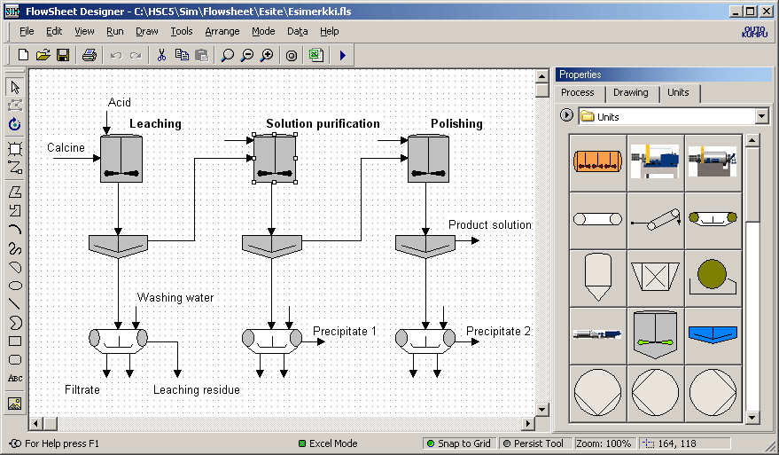

Outotec Research Oy
Information Service
P.O. Box 69
FIN - 28101 PORI, FINLAND

Fax: +358 - 20 - 529 - 3203
Tel: +358 - 20 - 529 - 211
E-mail: hsc@outotec.com ISBN-13: 978-952-9507-12-2
www.Outotec.com/hsc ISBN-10: 952-9507-12-7

Appendices

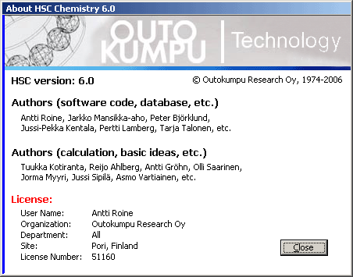
HSC-Sim development team

Appendices

Related reports 02103-ORC-T, 99079-ORC-T, 97036-ORC-T, 94027-ORC-T
Project number 240810, 240910
Keywords Thermodynamics, Thermochemistry

ISBN-13: 978-952-9507-12-2

ISBN-10: 952-9507-12-7

ABSTRACT

The traditional HSC Chemistry software was designed for various simulation and modeling applications based on independent chemical reactions and process units. The new HSC-Sim module expands the possibilities for applying HSC Chemistry to a whole process made up of several process units and streams.
The HSC-Sim module consists of graphical flowsheet and spreadsheet type process unit models. The custom-made variable list makes it possible to create many different types of process models in chemistry, metallurgy, mineralogy, economics, etc. Each process unit is actually one Excel file. The HSC AddIn functions may be used to turn these independent calculation units into small HSC engines for thermodynamic applications.
The process model created using the HSC-Sim flowsheet module consists of one FLS file with a graphical flowsheet and one XLS file for each process unit. These process files are always saved in the same file folder. The XLS files contain the calculation model of the unit, and these XLS-models may be reused in the other processes.
The target in HSC-Sim development has been to create a simple but still powerful simulation tool for the ordinary process engineer. If the user can use traditional HSC Chemistry and Excel software then he/she should be able to use also the new HSC-Sim module. The HSC-Sim module also has high quality and versatile graphics capabilities and visualization. For example, HSC-Sim module has built-in "Sankey diagrams" to visualize the distribution of the elements and process variables.
The HSC-Sim module also contains other sub modules besides the HSC-Sim Flowsheet module: however, this manual focuses only on the HSC-Sim Flowsheet module.
CONTENTS
40 HSC-Sim Flowsheet module 5
40.1 Brief Step-by-Step Start-up 7
40.2 HSC-Sim Basic Settings and Operations 9
40.2.1 HSC-Sim Specifications 9
40.2.2 Graphical Flowsheet Settings 11
40.2.3 Calculation Model Editor Settings 12
40.2.4 HSC AddIn Functions 13
40.2.5 Specification of the Drawing Area 14
40.2.6 Creating a Process Folder 14
40.2.7 Saving Files 15
40.3 Graphical User Interface 15
40.3.1 Toolbars and Menus 17
40.3.2 Properties / Process Toolbar 18
40.3.3 Properties / Drawing Toolbar 19
40.3.4 Properties / Units Toolbar 20
40.3.5 Drawing Toolbar (In Draw menu) 22
40.3.6 Rotate / Flip Toolbar (in Arrange menu) 23
40.3.7 Order Toolbar (in Arrange menu) 23
40.3.8 Combiner Toolbar (in Arrange menu) 23
40.3.9 Size Toolbar (in Arrange menu) 23
40.3.10 Alignment Toolbar (in Arrange menu) 24
40.3.11 Notes Toolbar 24
40.3.12 File Links Toolbar 24
40.3.13 Standard Toolbar (in File and Edit menu) 24
40.3.14 Tools Menu Selection 25
40.4 Drawing Flowsheets 27
40.4.1 Editing of Drawing Objects 31
40.4.2 Editing Unit Images 32
40.5 Creating a Variable List 33
40.6 Creating Calculation Models 39
40.6.1 Creating Distribution Model 40
40.6.2 Creating Reaction Equation Models 42
40.6.3 Creating Equilibrium Models 45
40.7 Specifying Raw Materials 47
40.8 Running Simulation 49
40.8.1 Visualize Settings Dialog 53
40.9 Printing 54
40.10 Element Balances of the Units 55
40.11 List of Streams - Variable Balances 56
40.12 Creating Controls 57
40.13 Remote Control - Scenarios - Sensitivity 60
40.14 Creating Reports 61
40.15 Global Cell Editor 62
40.16 Calculation Model Appearance and Format 63
40.17 Density of Aqueous Solutions 64
40.18 Password Protection of Units 67
40.19 Data Reconciliation 68
27. Excel Add-In Functions

40. HSC-Sim Flowsheet module
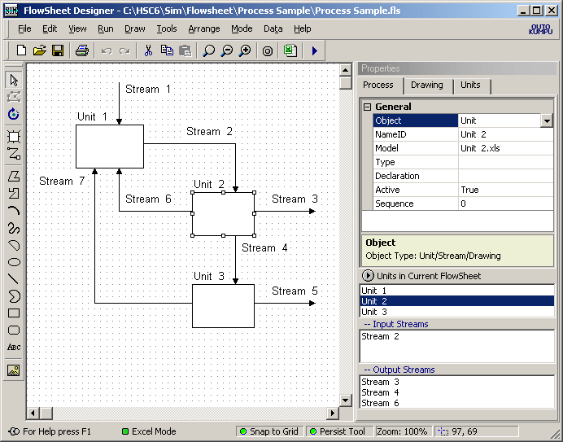
Fig. 1: HSC-Sim main user interface with flowsheet drawing and process calculation tools.
Most of the HSC Chemistry modules have been made for the simulation of chemical reactions in a single process unit. The new HSC-Sim module extends the scope to a whole process made up of several process units. The Sim module uses two main user interfaces: a graphical flowsheet interface (Fig. 1) and behind each process unit a spreadsheet type Model Editor interface (Fig. 2). The basic ideas of the Sim module are quite simple:
- The process consists of the process units which have been connected to each other with streams, Fig. 1. The flowsheet is saved in one FLS file.
- Behind each process unit there is a "small HSC engine" made of an Excel emulator with HSC AddIn functions or other DLL-based tools, Fig. 2. Nearly any types of model may be created using the Excel emulator, such as chemical, economic, biological, etc. These models may be reused because they are saved as independent XLS files.
- The process unit calculation models are independent of each other.
- The streams on the graphical flowsheet specify the material (= data and information) transfer and data exchange between the process units (FLS file).
- There are two modes in the HSC-Sim module: Designer Mode and Run Mode.
- The user draws and edits the flowsheet in the Designer mode, which is very similar to any other vector drawing program. In the Run (calculation) mode the graphical flowsheet is locked.
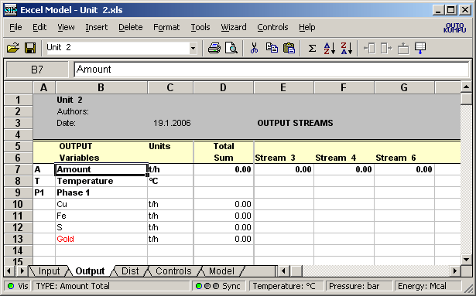
Fig. 2: HSC-Sim Calculation Model Editor. Output sheet shows the Output streams of Process Unit 2. Short variable list has been specified. Sync modes: A) Green: variable list within all units synchronized; B) Yellow: variable list within one unit synchronized; C) Red: synchronization OFF.
- The Calculation Module consists at least of Input, Output, Dist, Controls and Model sheets, Fig. 2. The Input sheet contains the input streams, the Output sheet the output streams, the Dist sheet possible distribution values, the Controls sheet possible controls, and the Model sheet possible calculation models. One stream always takes one column. The user can also add 251 sheets of his own if necessary, but these must be located after the model sheet. The format and syntax of the first four default sheets is partially fixed. The formats of your own sheets are free.
- In Run mode the calculation procedure recalculates units one by one downstream and after each calculation transfers the data from the source unit Output sheet to the destination unit Input sheet, according to the streams on the graphical flowsheet, Fig. 1. The calculation procedure transfers the values into the Input sheet stream columns, therefore you cannot use formulas in these columns, and i.e. the calculation procedure cuts any possible circular references between the units.
- The free-form and adaptable variable list makes the HSC-Sim module extremely flexible for any kind of simulation models in chemistry, electronics, economics, biology, etc., Fig. 3.
- The user models may be created using familiar Excel formulas and cell references. It is not necessary to learn some cumbersome macro languages. The HSC AddIn functions bring thermodynamics to these models. In future the range of AddIn functions and other DLL-tools will be expanded.
The template Model.XLS file in the HSC6 folder may be used to specify the default font, number, color and other visual formats of the model. Just like changing the style of the mobile phone by using different covers, Fig. 2.
40.1 Brief Step-by-Step Start-up

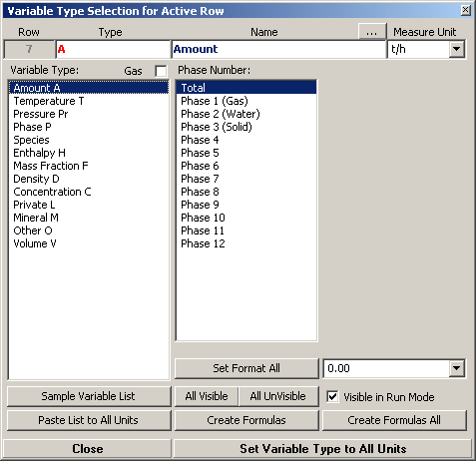
Fig. 3: Variable Type Editor. Variable type A has been selected for the active row.

The Sim module consists of versatile flowsheet drawing and process calculation tools. The use of the HSC-Sim module should be relatively easy because A) the drawing tools are quite similar to any other vector drawing program, B) the calculation model tools are quite similar to the Excel spreadsheet program procedures, formula syntax and options. The HSC-Sim development target has been to create a simple yet powerful simulation tool for the ordinary process engineer.
The HSC-Sim process model consists of the flowsheet and model files. These files are always saved in the same file folder, usually with the same name as the name of the process, see Chapter 40.2.7 Saving Files.
The following brief step-by-step list gives an idea of the main working procedures when a new process model is created using the HSC-Sim module:
- Select default measure units using Measure Units dialog, see Chapter 40.5, Fig. 37.
- Draw one unit on the flowsheet, Fig. 1, using Unit tool, Fig. 4, and open Model Editor by double clicking this unit, Fig. 2, see Chapter 40.4 Drawing Flowsheets.
- Specify the process Variable list either on the Input or Output sheet, Fig. 2. The Sync option at the bottom must be on "Green", because it will transfer this list to all units and sheets. See Chapter 40.5, Creating Variable List. The Sync mode "Yellow" means that the variable list is synchronized only within one unit. The Sync mode "Red" puts the synchronization totally off.
- Specify variable type using the Variable Type editor, Fig. 3. You may open Type editor by clicking the Type label at the bottom, Fig. 2. Variable type in column A is needed only by the model and formula wizards but not by the calculation procedure. In principle, if you do not use these wizards, then you do not need to specify variable types. Note that you may also manually write the type flag in column A. Fig. 2.
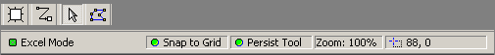
Fig. 4: The most important drawing tools: Unit, Stream, Select, Edit Stream Points and at the bottom the most important drawing options of Flowsheet form, Fig. 1.
- When you have specified all the variables and types then you may press the "Create Formulas All" button in Type Editor, Fig. 3. This will create default formulas in column D, Fig. 2. See Chapter 40.5, Creating Variable List.
- Draw the units and streams using the Unit and Stream drawing tools in the Designer mode, see Chapter 40.4. The icons of the most important drawing tools are shown in Fig. 4. They usually locate at the top left corner of the user interface, Fig. 1.
Note that the most important option tools may be controlled at the bottom of a flowsheet form, Fig. 1. The Snap to Grid option makes it easier to draw professional-looking flowsheets. Persist Tool remembers the last used drawing tool.
- Save the flowsheet using the File, Save As dialog, Fig. 1. It is recommended to create a separate file folder for each process. See Chapters 40.3 and 40.4 for details. It is a good idea to use the process name also as the folder name. The Sim module saves all the files in this same folder. This file-set consists of one FLS file with graphics and one XLS file of each unit.
XLS files use the Excel 2000 file format. FLS files can only be opened with the Sim module, but you may export these in other formats. Note: Save the process regularly using a different folder name or make backups of this folder using Windows My Computer. This makes it possible to recover the process if there is an error. See Chapter 40.2.7.
- Create the process models using the HSC-Sim Excel editor and wizards onto the Model sheet. These wizards automatically connect the Input streams with the Output Streams using some Excel type formulas and cell references. Note that you may also manually create these models. See Chapter 40.6, Creating Calculation Models.
- Start Run mode and carry out the simulation, see Chapter 40.8, Running Simulation.
- In Run mode select a variable and press Visualize, and this will show the distributions in graphical format. Chapter 40.8.
- Draw, print or copy-paste the results to other Windows applications using Run mode tools. Chapter 40.9.
The following chapters will give more detailed description of these steps. If you are planning to use HSC-Sim, please read at least Chapters 40.1, 40.2.7, 40.4, 40.5, 40.6, 40.7 and 40.8. But of course by reading all the chapters you may make your life easier in the long run.
40.2 HSC-Sim Basic Settings and Operations
This chapter gives information about the general settings of the Sim module. Usually you may start using Sim without changing the default values, but gradually you may want to change the default settings. HSC-Sim remembers the last selected settings using the files:
C:\HSC6\Sim_FlowSheet1.INI Drawing settings
C:\HSC6\Sim_FlowSheet2.INI Drawing interface settings
You may delete these files if you want to recover the original settings. If you have some problems with HSC-Sim operation then deleting of these files and restarting may help.
40.2.1 HSC-Sim Specifications
The HSC-Sim Flowsheet module works on Windows 98, Me, NT, 2000 and XP computers. However, a fast processor (Pentium 4 or AMD 64, > 2 GHz) with at least 256 MB of memory will smooth out operation a lot compared with, for example, some 500 MHz processor with small memory.
The maximum drawing area is currently limited to 1000 * 1000 mm, because some bitmap saving routines may become slow with large drawings. However, this limitation is easily removed. The dimensions and location units are always in millimeters.
The X- and Y- coordinates start from the top left corner and end at the bottom right corner of the drawing area. The printing area does not depend on the size of the drawing area, and any selection may be printed and zoomed freely to fit on A4, A3, etc.
The maximum number of drawing objects depends on the memory and processor capacity available. A normal PC can easily handle some 1000 objects. Note that gradient- based object fill styles consume a lot of processor capacity. In some cases speed may be improved by replacing vector-based (EMF) unit objects with gradient fill style with bitmap unit objects (JPG). The speed also depends on the settings, see Chapter 43.2.
Up to 32000 variables and data may be connected to each drawing object.
Flowsheet uses its own file format which uses the suffix *.FLS. This format saves all the available flowsheet properties. However, many other picture file formats may also be used to export and import pictures into the Flowsheet module.
Export file formats:
Import File Formats:
AutoCAD DXF Interchange R12-14 (*.DXF)
Windows Enhanced Metafile (*.EMF)
Windows Metafile (*.WMF)
CompuServe PNG (*.PNG)
CompuServe bitmap (*.GIF)
JPEG bitmap (*.JPG)
Windows bitmap (*.BMP)
Windows DIB (*.DIB)
AutoCAD DXF Interchange R14 (*.DXF)
Windows Enhanced Metafile (*.EMF)
Windows Metafile (*.WMF)
CompuServe PNG (*.PNG)
JPEG bitmap (*.JPG)
(Not Progressive JPEG)
Windows bitmap (*.BMP)

The calculation unit model limits are the same as in MS Excel 2000:
- Sheets 256
- Columns 256
- Rows 65536
HSC-Sim usually retains VBA macros in XLS files, but it does not run these macros. However, if you insert/delete sheets or rename sheets then VBA macros will be deleted.

40.2.2 Graphical Flowsheet Settings

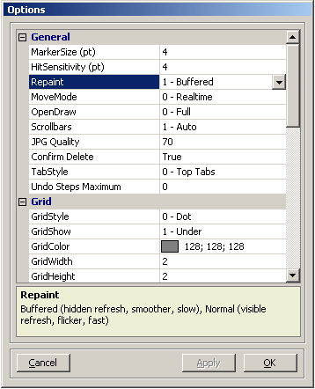
Fig. 5. Flowsheet settings dialog. Open this dialog using "View, Options…" selection.
The Flowsheet module automatically saves some 60 drawing settings, i.e. the program remembers the last settings you have used. However, with the View, Options selection you may manually change some of these default settings to meet your needs and preferences, see Fig. 5. The following settings are available:
General Settings:
Marker Size Selection handle size (default 4 points)
HitSensitivity Mouse pointer object detection distance (default 4 points)
Repaint Buffered (hidden refresh, smoother, slow)
Normal (visible refresh, flicker, fast)
MoveMode Real Time (whole object moves, slow)
Outline (object frame moves, fast)
OpenDraw Full (all objects visible, slow)
Container (internal object edit possible, not in use)
Hatched (only active object visible, fast)
ScrollBars Auto (X and Y scroll bars visible if needed)
None (no scroll bars, movement with right mouse button)
Default Font Font name, style, size, color
JPG Quality Compression percentage (only for saving in JPG format)
Confirm Delete Ask a confirmation for delete operations.
TabStyle Tab location in Properties Toolbar
Undo Steps Not in use

Grid Settings:
GridStyle Dot (dot is used as grid marker)
Solid Line
Dotted line
Dashed Line
GridShow None (no grid)
Under (grid under objects)
Above (grid above objects)
GridColor Color of grid points
GridWidth Distance between grid points (default 2 mm)
GridHeight Distance between grid points (default 2 mm)
SnapToGrid Align drawing object to grid

The Flowsheet module automatically saves Flowsheet module settings in two files:
C:\HSC6\Sim_FlowSheet1.INI Drawing settings
C:\HSC6\Sim_FlowSheet2.INI Drawing interface settings
The folder depends on your installation selections, these files exist in the same folder as Sim.EXE. If you delete these files in the C:\HSC6 folder then the Flowsheet module uses old default settings and automatically recreates these INI files.
40.2.3 Calculation Model Editor Settings
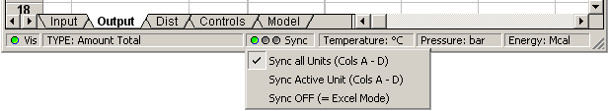
Fig. 6. Traffic lights, i.e. Sync modes: A) Green: variable list within all units synchronized; B) Yellow: variable list within one unit synchronized; C) Red: synchronization OFF.
The Calculation Model Editor has quite similar basic settings to MS Excel. You will find these from "Format" and "Tools, Options" menus. However, the Sync setting is different and very important. The "Green" mode is the default and this means that all variable list changes within all units (Input, Output, Dist sheets) are synchronized. Please use Green mode normally. However, if you import models you may use "Yellow" sync mode to arrange the variable list in the same order as in the other units. "View List Variables…" shows the default variable list. In "Red" mode you may edit sheets just like in Excel and without any locks; please be careful, in Red mode you may easily mess up the variable list.
The Template Model.XLS file contains all the default format settings of the calculation models. You may change format settings using MS Excel and by resaving this file back in the original location C:\HSC6\Template Model.XLS
Note: Do not insert or delete rows or columns in Input, Output, Dist or Controls sheets!
40.2.4 HSC AddIn Functions
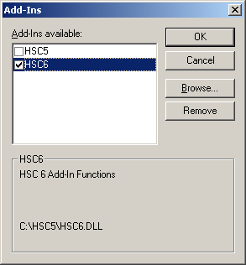
Fig. 7. HSC AddIn function selection and activation dialog
HSC AddIn functions are made for MS Excel and HSC-Sim Calculation modules, i.e. these same functions are available in both environments. HSC AddIn functions contain mainly chemical and thermodynamical functions which read the necessary data from the HSC thermochemical database.
All HSC-Sim AddIn functions are located in HSC6.DLL. HSC-Sim uses this file directly but MS Excel uses it through the HSC6.XLL interface. This interface is better than the old HSC Chemistry 5 HSC5.XLA interface, because the HSC6.XLL file path is not saved in Excel files in the same way as the HSC5.XLA file path. This makes HSC6.DLL AddIn-function files "mobile" and compatible.
You need to activate these functions only once using the HSC-Sim Calculation Module menu selection "Tools, AddIn Functions…". Please select only the new HSC6 AddIn functions and press OK, Fig. 7. If HSC6 is missing from the list then browse:
C:\HSC6\HSC6.DLL
You must activate these functions in the same way as in MS Excel. If HSC6 AddIn is missing from the list then browse (path may vary depending on original installation):
C:\HSC6\AddIns\HSC6.XLL
Using these AddIn functions you may create sophisticated thermochemical calculation models in your process units. See examples in: C:\HSC6\AddIns\AddInSample.XLS.
You will find a much more detailed description of these functions in Chapter "27 Excel Add-Ins.DOC" of HSC Help.

40.2.5 Specification of the Drawing Area
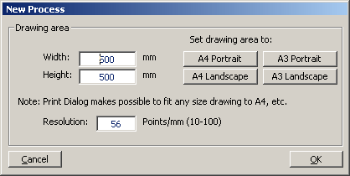
Fig. 8: New Process dialog clears and specifies the new flowsheet drawing area.
The first step when creating a new process is the specification of the Flowsheet drawing canvas area. This is done using the Menu selection "File, New…". This selection opens the drawing canvas area dialog, Fig. 8.
Usually the default canvas area 500 * 500 mm is just OK, because in the flowsheet printing stage any size of the drawing may be fitted or zoomed to A4 or any other size of paper. You can change the drawing canvas area later on using the menu selection "View, Drawing Area…". The Resolution selection may be used to increase or decrease the number of point per mm, the default 56 points is usually enough to create nice flowsheets.
40.2.6 Creating a Process Folder
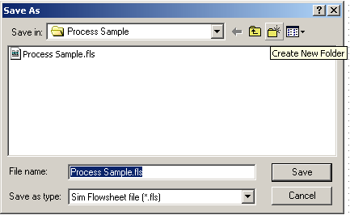
Fig. 9: The "Create New Folder" tool of the "File, Save As…" dialog may be used to create a new folder for the new process files.
Usually one HSC-Sim process consists of several files which are located in the same file folder. It is recommended to specify some name for the process at the very beginning, because this process name may be used as the name of the new folder, for example, "Process Sample" is the proper process name.
Menu selection "File, Save As…" and the "Create New Folder" tool may be used to create a new folder, Fig. 9. This new folder may be located in any place on your hard disk, but the default path is: C:\HSC6\Sim\Flowsheet\
You may also create this new folder using the Windows "My Computer" "File, New, Folder…" Dialog.
40.2.7 Saving Files
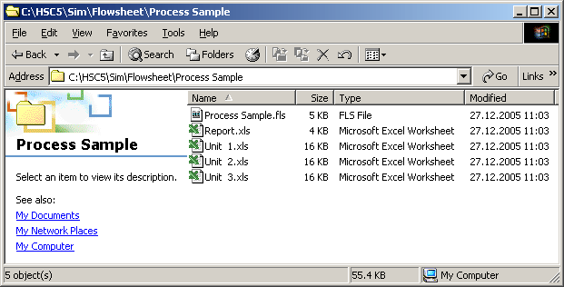
Fig. 10: HSC-Sim typical process files shown by Windows "My Computer".
The HSC-Sim based process model consists of several files which are always saved in the same file folder. The structure of the HSC-Sim process model is also visible in the process files, Fig. 10. The following steps are recommended:
- Create a separate folder for each process, use the same name for the folder and process. See previous Chapter 40.2.6.
- The "File Save" dialog automatically saves all process files in this folder.
Description of the process files:
- FLS files: Contain graphical flowsheet and stream data, etc.
FLS files use Sim’s own file format. However, Sim may also import and export other graphics file formats.
- XLS files: Contain Unit Models. The name must be exactly the same as in the graphical flowsheet, otherwise the XLS file will not be identified as the unit file. These files may be password-protected.
XLS files use MS Excel 2000 file format.
- Report.XLS file Contain possible result, stream, balance and remote control data.
The process folder may also contain many other files which may be linked to the graphical flowsheet, such as pictures, Word or Excel files.
It is recommended to save the process regularly using a different folder name or to make backups of this folder using Windows My Computer. This makes it possible to return to the earlier versions of the process if something unexpected happens.
Note also that you may import the Unit Model files to the other process models.
40.3 Graphical User Interface
This chapter gives some basic ideas of HSC-Sim flowsheet operation principles and keyboard and mouse procedures. You may start the Flowsheet module by pressing Flowsheet in the HSC-Sim main menu. The Flowsheet module works in quite a similar way to other object-based drawing applications such as iGraph Flowcharter, AutoCAD LT, etc.
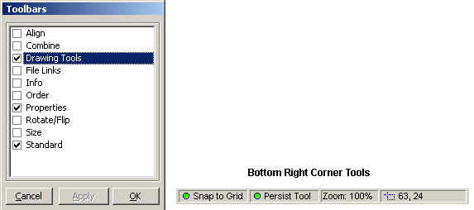
Fig. 11. View Toolbars menu. Toolbars selection shows or hides the Toolbars in the same way as in MS Excel or Word. You may move and resize toolbars with the mouse.
The following list specifies the main ideas of the operation procedures:
- View Toolbars (Fig. 11)
You may open View ToolBar dialog by selecting View, ToolBars from the menu. This dialog makes it possible to show or hide toolbars. The user may freely move and view/hide Toolbars in the same way as in MS Excel or Word. Toolbars are described in more detail in the next Chapter 40.13.
- Snap to Grid (Fig. 1, 2 Bottom right)
This setting helps to draw aligned diagrams. Note that you may reverse the Snap to Grid setting temporarily by holding down Alt Gr.
- Persist Tool (Fig. 1, 2 Bottom right)
This setting keeps the last selected tool. This is useful when you draw several similar objects.
- Mouse Tooltip Text
When you keep the mouse over the control you will get a short description of the tool.
- Drawing of Streams, Polylines, etc.
The first mouse click starts drawing, the second (etc.) makes a corner and a double click or Enter stops drawing. Backspace may be used to remove the last segment, Esc stops drawing to the last segment.
- Drawing of other Drawing Objects
Drawing starts when pressing the left mouse button down and stops when you release it. A double click on Select tool opens the Unit Model Editor.
- Object Type (in Properties, Process Tab)
The Type property lets you set any drawing object to Unit or Stream.
- NameID (in Properties, Process Tab)
If you want to connect Flowsheet to the calculation model then the NameID of Unit and Stream objects must be exactly the same as in the calculation model.
- Mouse Right Button
When you hold the right button down you may move the diagram.
- Mouse Wheel
The Wheel moves the drawing up/down. If you hold Alt Gr down then Zoom is activated.

Active Keys in Drawing Mode

Mouse left key Down - Starts drawing. Up – Ends drawing objects.
Enter Ends drawing of stream and polyline objects.
Esc Removes the last drawing object and Ends drawing objects.
BackSpace Removes last segment of stream and polyline objects.
Space Bar Starts and ends edit mode of streams and polylines.
Alt Gr Down - Temporarily reverses Snap to Grid mode.

Active Keys in Object Edit Mode (Chapter 43.5.14)

Mouse left key May be used to select object.
BackSpace Removes points if mouse left key is down.

Mouse left double click Opens Object Calculation Model.
Automatic Setting Memory
The Flowsheet always remembers the last user interface setting which you have used. These settings will be saved in INI files, see chapter 40.2.

40.3.1 Toolbars and Menus
The most important drawing and process tools may be found on the toolbars. Toolbars may be opened and hidden with the View, Toolbars dialog, see Fig. 11. The user may hide all Toolbars except the Properties toolbar, because it is nearly always needed. Most Toolbar options can also be found from the main menu, Fig. 12.
Fig. 12. Flowsheet main menu options.
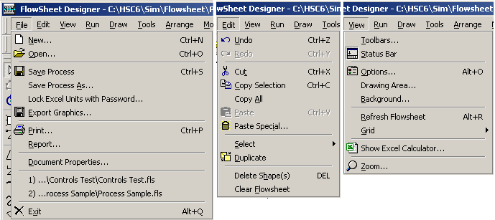
Fig. 13. Flowsheet main menu File, Edit and View options.
The main menu File selection contains the normal New, Open and Save selections as well as Printing dialog with settings and print preview, Fig. 13. Note that "Save Process…" dialog saves all the process files (FLS and XLS) into the same folder.
The Edit selection contains the normal editing options, Fig. 13. Note that most options work also with multiselection. The Undo option is also available, which makes it possible to go back several steps. However, it is recommended to save the flowsheet with different names, allowing recovery of the drawing if MS Windows operation fails.

40.3.2 Properties / Process Toolbar
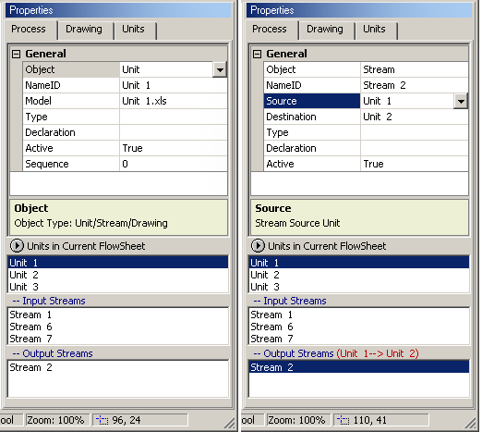
Fig. 14. Properties / Process Toolbar. Unit 1 is selected in the left toolbar and Stream 2 is selected in the right toolbar. The stream comes from Unit 1 unit and goes to Unit 2. The process toolbar shows all the possible properties at a glance.

The Properties toolbar is always visible in the Flowsheet Design mode with three tabs. The Process tabs specify the links to the model:
- Object: Stream / Unit / Drawing object
- NameID: Unique name for stream or unit.
- Model: Name of the unit file. The name is always the same as NameID.
- Type: Type of the unit or stream (reserved for future use).
- Source: Specify source unit of stream.
- Destination: Specify destination unit of the stream.
- Declaration: Any additional information in text format (default = empty).
- Sequence: Calculation sequence of the units (not required).
- Active: Link to calculation module on/off
The process tab also shows all available units and streams in the Flowsheet or in the active Process Model in the Calculation module. This list may be used to locate the unit and stream names and the source and destination units for the streams.
The Simulation Mode uses NameID to link the units and streams in the calculation module. Therefore the NameID property must be the same in the Flowsheet and Process model.
IMPORTANT: Please press Enter after you change data in the Toolbar cell. This is not always needed but it will ensure that the data really is taken into account.
40.3.3 Properties / Drawing Toolbar
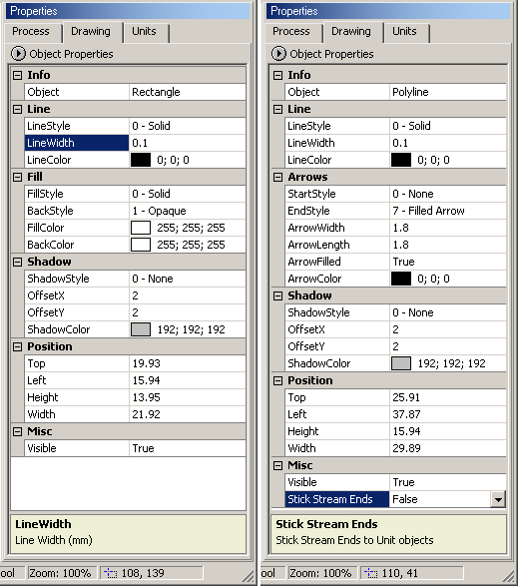
Fig. 15. Drawing Toolbar with Unit (Rectangle) and Stream (Polyline) object selected. The properties may be listed in alphabetical or categorized order.
The Drawing Toolbar shows all possible graphical properties of the selected object. The list of available properties depends on the object type. This enables you to see all the possible properties at a glance.
The Drawing properties have no effect on the possible process or distribution calculations, i.e. they are only used to improve the illustrative and cosmetic effect of the flowsheet.
The Drawing toolbar may also be used to relocate and resize the objects using numerical values in millimeters.
Multiselection of the same type of objects may be used to change the properties of all the selected objects at the same time.
NOTE: The Flowsheet module has an extensive selection of drawing properties and dialogs. Most of them are very easy to use and they operate in a similar way to many other drawing applications. Therefore these properties have not been described here.
IMPORTANT: Please press Enter after you change data in the Toolbar cell. This is not always needed but it will ensure that the data really is taken into account.
40.3.4 Properties / Units Toolbar
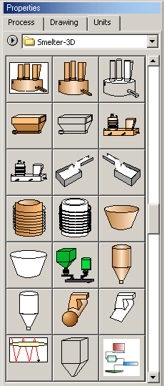
Fig. 16. Properties Toolbar with Units tab selected. The thumbnail pictures may be listed with or without the unit names.
The Units Toolbar, Fig. 16, contains the available unit images which may be used in the process flowsheet instead of simple rectangular unit objects. The unit images make the flowsheet more illustrative, in other respects they work in exactly the same manner as the normal units.
The user may select any unit image from the Units Toolbar and draw the image in the drawing area in the same way as the simple rectangle unit objects. Drag and Drop is another way to add unit objects to the drawing area, and this will also maintain the original image height/width ratio.
The available unit image collection depends on which Unit image folder is active. The Unit Toolbar reads all image files from this active folder. You may change this folder by selecting Browse. Press the round arrow button and select Browse. The unit images may exist, for example, in the following folders:
C:\HSC6\Sim\Units\Ferro\
C:\HSC6\Sim\Units\Hydro-3D\
C:\HSC6\Sim\Units\Smelter-2D\
C:\HSC6\Sim\Units\Smelter-3D\
etc.
The next time you start the Flowsheet module it will remember the last active Unit folder. You may add your own unit images into this or any other folder. If you would like a border around the unit image, please draw the border in the unit image. The following valid file formats must be used:
Vector formats (Good resize features):
EMF – Windows Enhanced Metafile (Recommended)
WMF – Windows Metafile (old format)
Note that a large number of color gradients may make the image slow to access and move.
Bitmap formats (Fast, resize difficult, fixed size looks best)
JPG – JPEG format (small file, common). Note: Progressive JPEG format does not work.
BMP – Windows bitmap (large file, common)
Color gradients have no effect on the speed in bitmap format.
Unit images may be drawn using the Flowsheet module or using any drawing application which saves files using the valid file formats. You may also replace the simple rectangle unit objects with the unit images using the “Tools, Change Picture…” dialog.
Create New Unit Image
You may create new unit images using normal HSC-Sim drawing tools and save any selected image as unit. To create a new unit image follow these steps:
- Draw a unit image in the size you would like to be the default size. Of course you may draw in large size and reduce the size before the saving stage.
- Select unit drawing objects with the Select tool.
- Open the “Tool, Save Selection To Unit” dialog and give the default name for the unit, then save the unit image in the folder where you want it to be. The unit file name will be used as the unit name in the Flowsheet. The EMF file format makes it possible to resize the unit image easily. Bitmap formats may sometimes be faster to use.
- If you save the unit file in the same folder which is already open in the Unit toolbar, then the list will be refreshed automatically.
Note that you may create unit images in any drawing application which saves image files in EMF, JPG or BMP format. Large size bitmap files, for example, 3000*2000 pixels may be used but they will slow down the operating speed. Usually small 80*60 pixel unit images are OK.

40.3.5 Drawing Toolbar (In Draw menu)

1 2 3 4 5 6 7 8 9 10 11 12 13 14 15 16 17 18 19 20 21
Fig. 17. Drawing Toolbar in horizontal mode.
Drawing tools may be selected from the Drawing Toolbar, Fig. 17 or from the Draw menu selection, Fig. 12. The basic idea is that the user first selects the tool and then he/she can start to draw the selected object with the mouse. The following tools are available, see Fig. 17:
- Drawing Toolbar Drag Drop area.
- Select tool. This tool is used to select objects in the drawing area.
- Rotate tool enables you to rotate objects freely. The other rotation options may be found from the Rotate/Flip Toolbar.
- Unit tool creates rectangular units and labels. The Properties Units Toolbar, Fig. 16, may be used to create units with an image.
- Draw Fixed Polyline Stream tool creates polyline streams and labels. These streams do not stick with the unit objects. This may seem annoying in some cases, but often makes the editing of the flowsheet much more straightforward. You may open the edit mode using the Edit Points icon or by pressing SpaceBar after selecting a stream line.
- Draw Direct Stream creates straight stream lines which stick on the source and destination units. The stick point may also exist within the unit object (not in use, instead use Stick Stream Ends property, Fig. 15).
- Draw Polyline Stream creates polyline stream lines which stick on the source and destination objects object (not in use, instead use Stick Stream Ends property, Fig. 15)..
- Draw Direct Midpoint Stream creates stream lines which start from the midpoint of the unit object but are visible only outside the unit object boundaries. These are not usually used in chemical process flowsheets object (not in use, instead use Stick Stream Ends property, Fig. 15)..
- Draw Polyline Midpoint Stream creates stream lines which start from the midpoint of the unit object but are visible only outside the unit object boundaries. These are not usually used in chemical process flowsheets object (not in use, instead use Stick Stream Ends property, Fig. 15)..
- Draw Polygon creates closed polygons which have fill and shadow properties. Note that you may easily add new points and edit the location of the existing points later on by double clicking the polygon using Select.
- Draw Polyline creates open polylines.
- Draw Arc creates elliptical arcs.
- Draw Bezier creates Bezier curves.
- Draw Chord (Segment) creates Chord objects.
- Draw Ellipse creates ellipse or circle objects.
- Draw Line creates simple lines.
- Draw Pie creates elliptical sector objects.
- Draw Rectangle creates rectangular objects.
- Draw Rounded Rectangle creates rounded rectangular objects.
- Text creates text labels.
- Insert Image inserts bitmap or vector format images from the file to the flowsheet.
Active keys in drawing mode: With Polyline objects the Backspace key removes the last segment, the Esc key removes the object, Enter ends drawing. See Chapter 40.4.1 for more information.
40.3.6 Rotate / Flip Toolbar (in Arrange menu)
1 2 3 4 5 6
Fig. 18. Rotate / Flip Toolbar rotates the objects
- Rotate/Flip Toolbar Drag Drop area.
- Rotate clockwise 90°
- Rotate counter-clockwise 90°
- Rotate to given angle
- Flip Horizontal
- Flip Vertical

40.3.7 Order Toolbar (in Arrange menu)
1 2 3 4 5
Fig. 19. Order Toolbar brings the object layers to the front or sends them back.
- Order Toolbar Drag Drop area.
- Send to Back sends object layer to the back
- Bring to Front sends object layer to the front.
- Send backward one layer.
- Bring forward one layer.

40.3.8 Combiner Toolbar (in Arrange menu)

1 2 3
Fig. 20. Combiner Toolbar combines objects.
- Combiner Toolbar Drag Drop area.
- Group Objects tool combines the selected objects
- UnGroup tool uncombines the selected objects

40.3.9 Size Toolbar (in Arrange menu)

1 2 3 4
Fig. 21. Size Toolbar may be used to make the height or width of the selected object the same.
- Size Toolbar Drag Drop area.
- Make same width tool makes the selected object’s width the same.
- Make same height tool makes the selected object’s height the same.
- Make same width and height tool makes the selected object’s width and height the same.
40.3.10 Alignment Toolbar (in Arrange menu)

1 2 3 4 5 6 7
Fig. 22. The Alignment Toolbar can be used to align selected objects.
- Alignment Toolbar Drag Drop area.
- Align to Left will align the selected objects to the left border of the top object.
- Align to Center will align the selected objects to the center of the top object.
- Align to Right will align the selected objects to the right border of the top object.
- Align to Top will align the selected objects to the top border of the left object.
- Align to Middle will align the selected objects to the middle of the left object.
- Align to Bottom will align the selected objects to the bottom of the left object.

40.3.11 Notes Toolbar

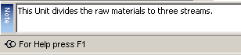
Fig. 23. The Notes Toolbar can be used to save text data to unit, stream or graphical objects.

40.3.12 File Links Toolbar
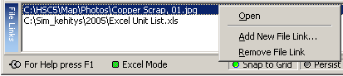
Fig. 24. The File links toolbar makes it possible to link any types of files to a unit, stream or any other graphics objects on the flowsheet. For example, you may link a photo of the unit, unit data history, etc. Using the Links toolbar you can connect additional information onto the flowsheet.

40.3.13 Standard Toolbar (in File and Edit menu)

1 2 3 4 5 6 7 8 9 10 11 12 13 14
Fig. 25. Standard Toolbar in horizontal mode.
Standard toolbar contains the normal tools for file save, printing, etc.
- Standard Toolbar Drag Drop area.
- New Flowsheet will delete the existing flowsheet and create a new one.
- Open selection will start the File Open dialog and replaces the existing flowsheet.
- Save File will run the File Save dialog for saving the flowsheet.
- Print dialog opens the print settings and print dialog.
- Undo selection will undo the last action. Several undo levels are available.
- Redo will cancel the last Undo operation.
- Cut will copy and delete the selected objects.
- Copy will copy the selected objects.
- Paste will run the paste routine.
- Zoom will open the Zoom dialog. You may also zoom with the mouse wheel by holding down the Alt Gr key.
- Zoom Out will decrease the zoom setting by 10% units.
- Zoom In will increase the zoom setting by 10% units.
- Start Simulation will run the flowsheet in simulation mode, which makes it possible to connect the flowsheet with the process calculation module.

40.3.14 Tools Menu Selection
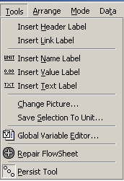
Fig. 26. Tools menu selection contains some important and useful tools.
Insert Header Label inserts a special Header label on the flowsheet, which shows the variable selection in the Simulation mode, for example, As kg/h, Amount kg/h, etc.
Insert Link Label inserts a Link label which may be used to show value of any cell in the calculation models in the spreadsheet.
Insert Name Label can be used to insert a name label in the Unit or Stream objects.
Insert Value Label can be used to insert a value label in the Unit or Stream objects, which will show the selected variable value in Simulation mode.
Insert Text Label can be used to insert a text label in the Unit or Stream objects.
Change Picture inserts an image in the selected unit or area object.
Save Selection To Unit can be used to create a new Unit image file. First draw any kind of unit image and then select all the graphical objects which belong to the unit. Then save the selected objects as a unit image using “Save Selection To Unit”. The unit images may be saved in EMF (recommended), JPG and BMP file format. Please note! only EMF may be resized without loss in image resolution.
Global Variable Editor Not currently in use, because the Sync modes have replaced this dialog. However in future Sim versions this dialog may be reactivated.
Repair Flowsheet Updates the old Sim 5.x flowsheet to the current Sim 6.0 format.
Persist Tool keeps the last selected tool after the drawing has been finished.

40.4 Drawing Flowsheets
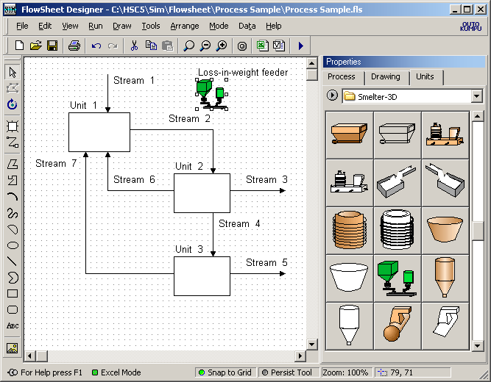
Fig. 27: Flowsheet module main drawing tools on the left toolbar and image unit thumbnail browser on the right.
You can draw the flowsheet first and then specify the variable list or vice versa. The most important drawing tools and options are shown in Fig. 28. Usually the Snap to Grid should be always on, which makes it easy to align the objects drawn. You may sometimes need to set Snap to Grid off in order to fine-tune the locations of the text Labels. You may get the same effect by holding down the Alt Gr key and moving the objects with mouse. The Persist Tool keeps the last used drawing tool in the memory.
Fig. 28: The most important drawing tools and drawing options, see Fig. 14 for locations of these tools. The drawing tools are: Unit, Stream, Select and Edit Stream Points.
First, select the Unit tool and draw some units by clicking the drawing canvas with a mouse and keep the mouse’s left button down while drawing. Note that you may also select image units from the Units thumbnail browser, see Fig. 16. These image units may look better but sometimes they make the flowsheet fussy. The basic units and image units behave exactly in the same manner in the flowsheet, and you may later on insert new images into the basic units, using Tools, Change Picture.. dialog.
The next step is to draw the Streams which connect the units. First, select the Stream drawing tool, Fig. 28, click the start point of the stream and do NOT keep the mouse button down when drawing. Draw the stream simply by clicking on the corner points of the stream; and to stop the drawing, press Enter or double click the end point.
NOTE: Please do not resize the streams using selection handle (sizing handle) as this will also resize the arrow heads. If you want to move the location of the polyline stream points then:
1. Select the stream and press the Edit Stream Points icon, see Fig. 29, or press the Space Bar.
2. The stream points turn yellow and then you may move these points using the mouse.
3. You may add new points by clicking and moving on the stream line.
4. You may remove points by selecting the point and keeping the mouse’s left button down while pressing Back Space on the keyboard.
5. When you are ready, please press Edit Points icon once again or press the Space Bar.
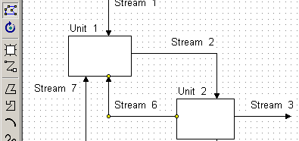
Fig. 29: The Stream 6 has been selected for editing. You may move the yellow points with the mouse and add new points by clicking the line and delete selected point with BackSpace.
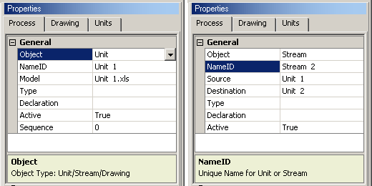
Fig. 30: Unit and Stream drawing object main properties.
The most important properties of the units and streams may be found from the Process tab of the Properties Toolbar, see Fig. 30. The essential properties have been underlined:
Object: The object property specifies the graphical object type. The Sim calculation routine uses this property to specify the units and streams. You may change this property, but please be careful.
NameID: NameID specifies the name of the unit or stream; you may change these names, but duplicate names are not valid.
Model: The model property specifies the file name of the unit model, which must be the same as the unit name. The Unit files are located in the same folder as the FLS flowsheet file.
Source: The ource property specifies the source unit of a stream object. A question mark "?" means that the source is a raw material.
Destination: The destination property specifies the destination unit of a stream object. A question mark "?" means that the destination is a product stream.
Please note that Sim calculation routines use Source and Destination properties to identify the source and destination of the streams. In other words, if there is disagreement with a source between the source property and graphical flowsheet then the Sim calculation routines use the Source property. This means that you do not need to draw very long and complicated streams on the graphical flowsheet, instead it is sufficient that you specify the Source and Destination properties.
Type: Type of the unit or stream. Reserved for future Sim versions.
Declaration: You may give some additional information in this field, usually it is empty.
Active: You may use this property to temporarily deactivate the unit or stream.
Sequence: Normally the units are recalculated downstream; however, with this property you may force to recalculate units in a given order. Value "1" in this property forces to recalculate this unit first. In some cases this property may be used to improve the convergence and speed of the iterations.
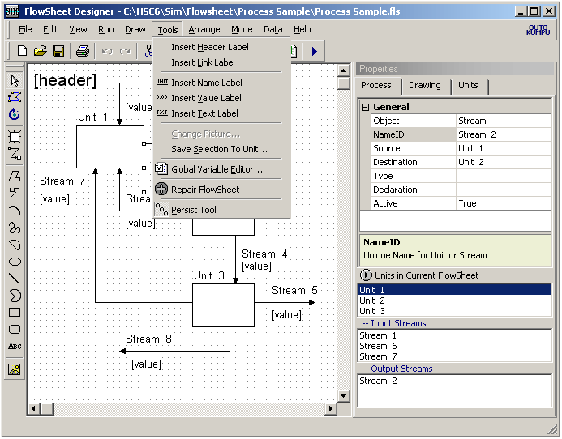
Fig. 31: Flowsheet main menu Tools selection. The Insert Header Label and Insert Value Label may be the most important tools in this sub menu.
When you have got the drawing ready you may add some additional labels, see Fig. 31.
For example the Header label may be very useful when you visualize the calculation results in the Run mode. You may add the Header label with selection "Insert Header Label". The top left and top right corner is often a good location for the header label, which shows the selected Variable name in the Run mode, see Fig. 31.
The Link Label can be used to show any cell value from the calculation models in the flowsheet. By using the "Link CellRef" property of link label, you may pick up the active cell reference into this property or you may type it manually.
The Value Labels can be used to show the actual value of selected variables in the stream in the Run mode. First, select the stream then select the Insert Value Label from the Tools, menu, see Fig. 31. You can easily relocate the labels using the mouse. Usually the Value Label [value] is added to all the streams, see Fig. 31.
40.4.1 Editing of Drawing Objects
With the Select tool you may select objects for editing. The Properties Toolbar may be used to change the properties and location of an object. However, the shape of the object can be changed in the object edit mode only. You may start the edit mode by pressing Edit Points icon, Fig. 28, or pressing the Space Bar when object is selected. The edit procedure depends on the object type. The following pictures give a brief introduction to the editing possibilities.
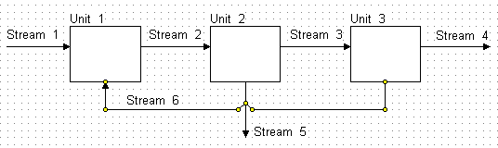
Fig. 32. Editing of Fixed Polyline Stream, polyline, polygon and Bezier objects:
- Move yellow points with mouse (mouse pointer must be cross arrow).
- Add new points by clicking on the line
- Remove points with Backspace key (hold left mouse button down).
- You may change the source and destination units from the Process Toolbar.

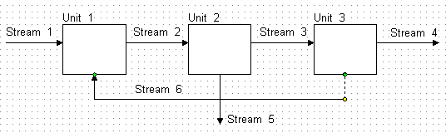
Fig. 33. Editing of Polyline Stream and Polyline Midpoint Stream objects:
- Yellow points may be used to move the location of the whole line.
- Green points may be used to move the start or end location.
- The stream line always keeps the original source and destination units. You cannot change these in the Process Toolbar!
- Draw a new stream if you want to change the source or destination units.

NOTE 1: If you are drawing a new polyline object then:
Backspace removes the last segment.
Esc removes the last segment and ends the drawing.
Enter ends the drawing.
NOTE 2: The OpenDraw setting, Fig. 5, has a great effect on the appearance of the flowsheet in the edit mode. However, it has no effect on the procedure.
40.4.2 Editing Unit Images
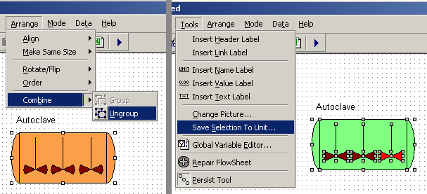
Fig. 34. Ungroup unit object and save it back to unit.
The user may edit unit images. However, these images must first be ungrouped into basic graphical objects. These basic graphical objects may be edited in the normal way. The final step is to save selected objects into one unit image. The steps may be summarized as follows:
1) Select the unit.
2) Select "Arrange, Combine, Ungroup...".
3) Change, for example, the line or fill colors of the drawing objects.
4) Select all drawing objects again.
5) Select "Tools, Save selection to Unit...", save as EMF format.
This procedure may be used to create new unit images in different file formats.
40.5 Creating a Variable List
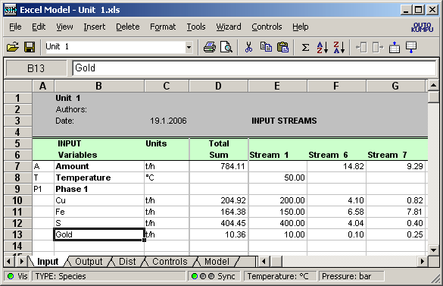
Fig. 35: Sim Input-sheet with a simple variable list. You can type the list directly in column B and by clicking the TYPE label, you can specify the variable type and measure unit.
The custom-made variable list makes it possible to utilize the HSC-Sim module in many different types of simulation applications, such as mineralogical, chemical, hydrometallurgical, pyrometallurgical, economic, biological, etc. Only your imagination sets the limits! The custom-made variable list gives a lot of flexibility but the drawback is that the user must know what he/she is doing.
This is also the main reason why the specification of the variable list is one of the most important tasks in the new model development stage. You may easily add/delete/edit/sort the variable list later on, but still it may be best to try to specify a complete variable list right at the beginning or at least before you start to create the calculation models.
The most important selection you must make when creating the variable list is the format of species (= format of material). There are two options:
1. Elements (Fe, Ag, O, etc.): This makes it possible to calculate the element balances of the units and is often the best selection when using quite simple models.
2. Species (Na2S, CaCO3, CO2(g), H(+a), CO3(-2a), etc.): This selection makes it possible, for example, to calculate enthalpies of the input and output streams and the energy balances. This format is recommended for the more complicated models.
Another very important task is to divide the species into meaningful phases because only this makes it possible to calculate phase properties like densities and compositions, Fig. 39.
IMPORTANT NOTE: The Sync option must be ON, see Fig. 35. It synchronizes the Input, Output and Dist sheet columns A - D with each other.
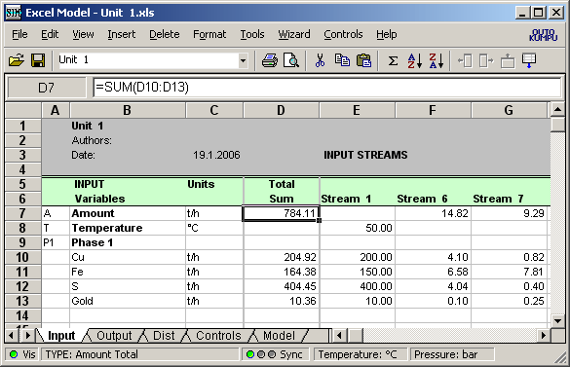
Fig. 36: Sim Input-sheet with a simple variable list. You may create column D formulas automatically by using the "Create Formulas All button on Type dialog, Fig. 3.
The first step is to type the variable list straight into the Input or Output sheet column B, Fig. 35. The font color turns from black to red if the variable is not found from the HSC main database. However, this does not cause any problems if you do not use the Sim thermochemical AddIn functions. For example, the word "Gold" in Fig. 36 cannot be found from the HSC database, however, it may be used as a variable name.
The next step is to specify the variable types, Fig. 36. The model sheet wizards use the variable type specification in column A for formula and cell reference generation. If you do not use wizards, then you do not need to specify the types. However, it is recommended to carry out the type specification in any case because it makes the variable list easier to read.
The meaning of the Input, Output and Dist sheet columns may be summarized as follows:
Column A - Type: Specifies the Row Type. Basically the Type column does not have any effect on the calculations, however, the Wizards use Type information when they create the calculation formulas. The Type parameter may be specified using Type Dialog, Fig. 3. The possible selections are:
- A Amount
- T Temperature
- Pr Pressure
- P Phase
- Species. Red font = cannot be found from HSC database.
Note: You may press "Mouse right button to browse HSC database.
- H Enthalpy
- F Mass Fraction (Base species must be specified)
- D Density (Aqueous phase species mass fractions must be specified)
- C Concentration
- L Private
- M Mineral
- O Other
- V Volume
The number section in the row type parameter means the phase number. For example: A2 = Amount of phase 2, H3 = enthalpy of phase 3, etc.
NOTE: It is recommended to introduce the variables always in the above order; this makes the reuse of the unit models in different processes much easier, because the variables must be in the same order within one process!
The species are recommended to divide into meaningful phrases such as "Gas Phase", "Water Phase", "Pure Substances", etc. The phases should be introduced as a continuous list! Wizards are not able to generate, for example, Enthalpy or Amount formulas without the specification of phase and species variables, Fig. 36.
Column B - Variable: Specifies the Variable Name. The Wizards use a variable name to identify the variables but the simulation calculations do not utilize this name. The calculation routines transport stream variable data between units as columns and assume that the order of variables is the same in all the units.
Column C - Unit: Specifies the measurement unit. Please use the same measurement units within all the process unit models. In the future HSC-Sim versions, more flexibility will be added to the measure unit column.
Column D - Formula: Specifies the Excel type cell formula which will automatically be added into the Excel model Input - and Output-sheets in Column D. This same formula will also be used by the output stream columns on the Output-sheet.
Columns E-> - Streams: Each stream has one own column.

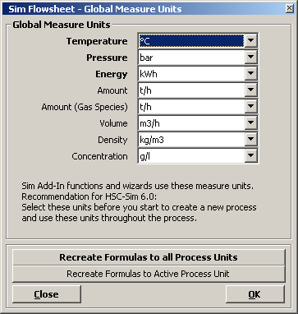
Fig. 37: HSC-Sim Global and AddIn function default units.
The default measurement units are shown at the bottom right of the Model Editor form, Fig. 36. You may change these by clicking the unit labels. The Global Measure Unit dialog makes it possible to change these units, Fig. 37. It is recommeded to select the measure units when you start to create a new process, the wizards add these units into column C, Fig. 36.
Do not use HSC AddIn function =Units("C";"MJ") on your model sheet, because this AddIn function may overwrite the global setting and cause random results. See examples, of AddIn-functions syntax from: C:\HSC6\AddIns\AddInSample.XLS.
Note that the Global Measure Units do not automatically change the measure units which have been used within the Input, Output, Dist, Control and Model sheets. For example, if the AddIn function returns the enthalpy as Mcal you may easily convert these values to MWh in your Model sheet by multiplying by 1.162.
In the next HSC-Sim versions, the Wizards will be tuned to accept a wider range of different measure units.
A variable list sample is shown in Fig. 38. It has been created with the Sample Variable Listkey, see Fig. 3. Note that the species have been divided into phases. The phase list must be continuous i.e. do not use empty rows within the list.
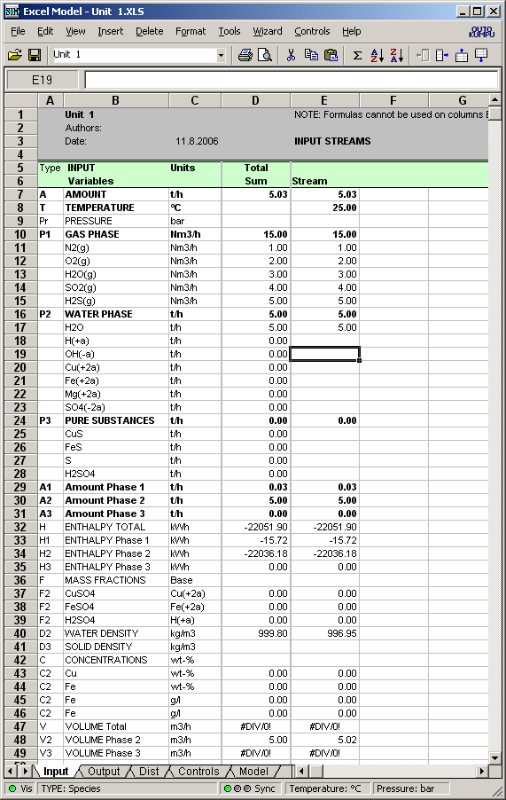
Fig. 38: A variable list sample with variable type specifications in column A. The formulas in column D have been automatically created. The raw materials have not yet been introduced. Most types have been attached with a phase number, for example, H2 is the enthalpy of phase number 2.

40.6 Creating Calculation Models
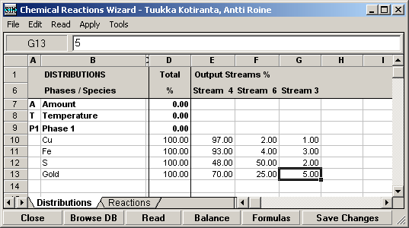
Fig. 40: Output stream distribution Wizard may be started from the Model Editor Wizard menu.
The calculation model creates a mathematical connection (model) between the Input and Output streams of one Unit. Usually this model may be divided into two parts:
1. Main Model - chemical, mineralogical, equilibrium, flotation, filter, etc.
All the input material streams are combined and then the calculation model transforms the raw materials into products by using some mathematical formulas based on chemistry, physics or economy. The Sim-Wizard creates a main model onto the Model sheet. The main model may also be called the Transformation model.
2. Distribution Model - based on distribution percentages
The Distribution model divides the products of the main model into the Output streams. If there is only one output stream then 100% of the products enter this stream. The Sim Wizard creates a Distribution model on the Dist- and Output- sheets.
The basic idea is that the unit models (Unit 1, Unit 2, Unit 3, etc.) are independent and do not have any information about each other. The graphical flowsheet contains the information of the stream connections between the units. The calculation routine transmits the information (data) between the calculation units according to the graphical flowsheet Source and Destination properties. This unit "autonomy" concept makes it easier to reuse units in other processes.
However, sometimes some special information needs to be transmitted between the units, and in these cases external links may be used. The external link syntax is quite simple: The formula: "=[Unit 2]Dist!G7" links cell into cell G7 of Dist-sheet in Unit 2. When you reuse this kind of unit model in some other process you must remember to check the external links. Note that External Links may also generate troublesome "Circular References" unlike the normal data transferred using stream variables.
40.6.1 Creating a Distribution Model
Even the simplest main model which only combines the Input materials feeds without any transformations needs a distribution model. Distribution percentages may be typed manually into the Dist sheet. However, the Distribution Model Wizard offers an easier way, Fig. 40. The first step is to open Distribution Wizard from the Wizard menu, the second step is to type the distribution percentages into the variables, Fig. 40. The last step is to press Save Changes and Close the Wizard. This procedure must be repeated for each unit.
The Apply Distributions procedure creates the Main Model on the Model sheet, Fig. 41, fills the Dist sheet, Fig. 42 and updates formulas on the Output sheet,. Fig. 43. These formulas divide the Main model products into Output streams.
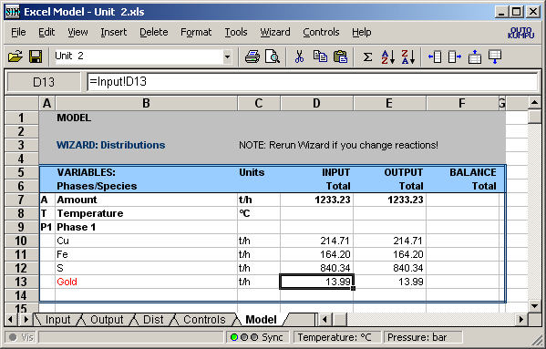
Fig. 41: Distribution Wizard creates the Main Model. In this case the total sum of each input variable ends up in the output streams without any variable transformations.
The Chemical Reactions Wizard may be used to create more sophisticated Main models based on the chemical reactions. You may also create your own models manually using Excel formulas, cell references and Sim AddIn functions on the Model sheet or on your own sheets. However, your own sheets must be located after the Model sheet!
The chance to create a customized variable list and your own main models using familiar Excel type syntax makes HSC-Sim very flexible for many types of simulation applications.
One unit model is always one file in Excel 2000 file format. This makes it possible to reuse models in other processes. However, the order of the variable list must be the same. In this sense it is a good idea to use the same variable list in all your processes in spite of the fact that some of the variables are not needed (amounts = 0) in all applications.
Please note that you can also create your own models under MS Excel, since HSC-Sim AddIn functions also operate under Excel. However, please use the "C:\HSC6\Template Model.XLS" file or some original Sim model file as a template for your own models. Do not delete or overwrite the "Template Model.XLS" file because Sim uses this file as a template. In MS Excel you may create your own VBA macros for different calculation models. HSC-Sim usually retains VBA macros in XLS files, but it does not run these macros.
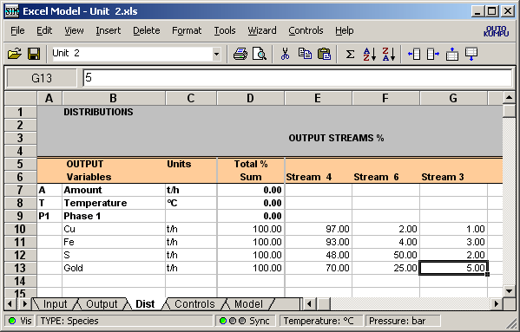
Fig. 42: Distribution Wizard fills Dist sheet with given distribution percentages.
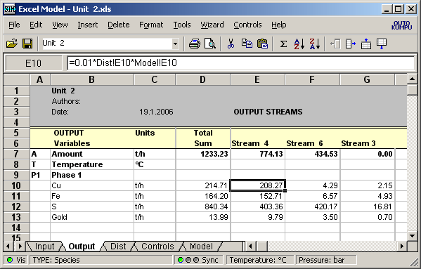
Fig. 43: Distribution Wizard updates formulas on the Output sheet.
40.6.2 Creating Reaction Equation Models
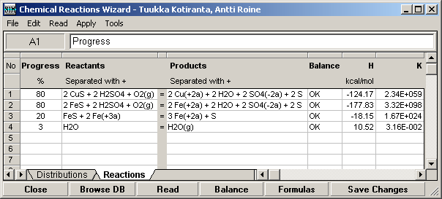
Fig. 44: Distribution Wizard updates formulas on the Output sheet.
The main calculation model transforms the input variable values into output variable values using some mathematical formulas. The main model may be created manually as in MS Excel on the Model sheet or by using HSC-Sim Wizards. Quite often the main model is based on the chemical reactions. In this case you may open the Chemical Reactions Wizard using selection "Wizard, Chemical Reactions Model…" from the Model Editor menu, Fig. 2.
The first step is to type the reactions that may happen in the process unit in the Chemical Reaction Wizard, Fig. 44. You may use the Browse DB button to check the correct syntax for the species from the HSC active databases.
The first species of each reaction is assumed to be the "raw material" which is consumed in this reaction. You must keep in mind that you cannot consume more than 100% of the raw materials. For example, FeS is the raw material in two reactions 1 and 2, Fig. 44. The sum of Progress % cannot be more than 100% (80% + 20%), although it can be less than 100%. The next species in the reaction equations will automatically be taken into account when model is created on the basis of the reaction stoichiometry. However, it is still recommended to check for the negative amounts in the Model-sheet and remove these, for example, by decreasing Progress %.
The second step is to test the balances by pressing the Balance button. This gives an OK in the Balance column, showing that everything is OK. The balance test will also give enthalpy H and equilibrium constant K for the reaction at 25 °C if all the species are found in the active HSC databases. Negative H values mean that heat is released in the reaction, whereas positive values mean that more heat is needed. Large K values (>1) mean that the reaction tends to go to the right and small values (<1) mean that the reaction tends to go to the left in the equilibrium state.
Please remember to fill in the Distribution sheet too, Fig. 44, because you must divide the products into the output streams.
When you are happy with the reactions and distributions press Save Changes and close the dialog. This will create both the main model and distribution model on the Output, Dist and Model sheets.
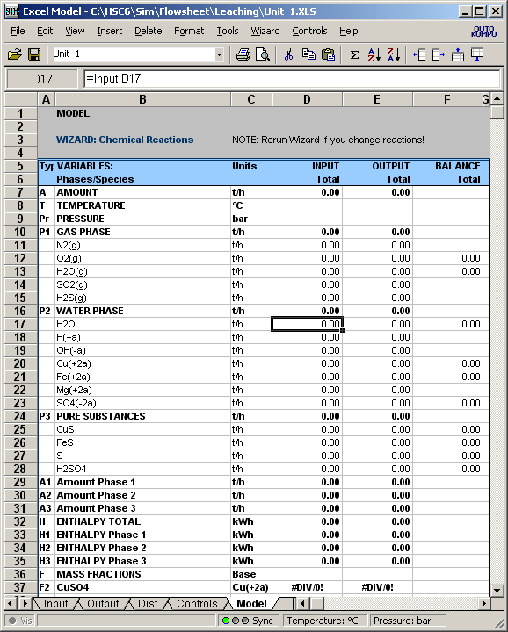
Fig. 45: Balance range of the main model made by the Distribution Wizard.
The Distribution Wizard automatically creates the Balance range and Chemical Reaction range in the Model sheet. The Balance range contains Input, Output and Balance formulas which summarize the total input and output amounts of the variables. Usually the balances are not zero if variable transformations (reactions) occur in the unit, Fig. 45.
Note that if the species name is red this means that species is not found in the active HSC databases. This will not cause any problems with the element balance calculations, but if you would also like to calculate energy balances then the share of this unknown species will be missing from the energy balance.
An automatically filled range is outlined with a double line border. Please do not change the formulas within this range if you are not absolutely sure of what you are doing.
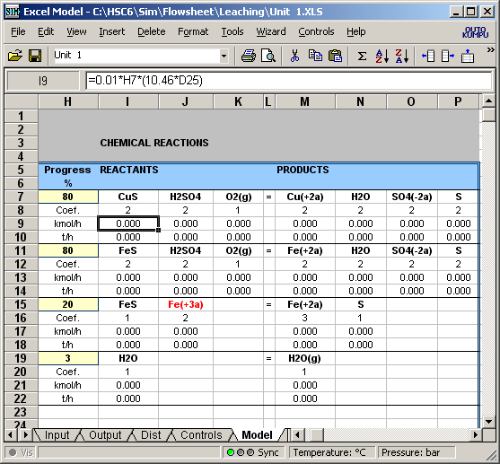
Fig. 46: Reactions range of the main model made by the Distribution Wizard.
The Reactions range contains the list of the reactions with progress percentages and necessary cell formulas to calculate the reacted and produced amounts of the species. You may change the Progress% cells manually, for example, H7 and H11. Please do not change the other cells within this area that have been outlined with the double line border.
Note that the species name is red if this species is not found in the variable list. This may lead to errors. In this case the red color of "Fe(+3a)", Fig. 46, means that Fe(+3a) will be not copied to the output sheet and this will cause material balance error. Please add Fe(+3a) into the variable list and rerun the Wizard. In case of electrons the red color does not matter as long as we are not interested in electron balances.

40.6.3 Creating Equilibrium Models
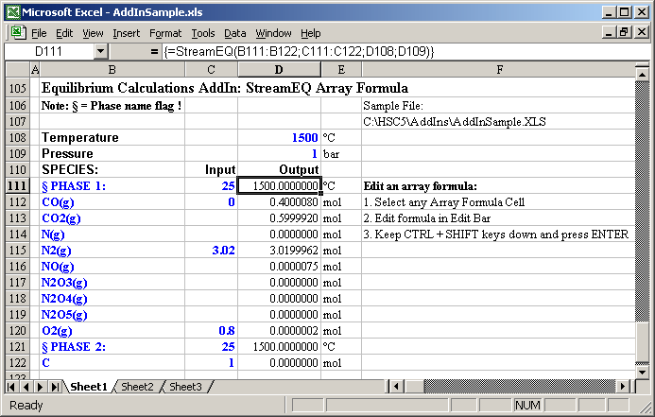
Fig. 47: HSC StreamEQ AddIn function calculates the equilibrium amounts (mol) of the stream at given temperature 1500 °C and pressure 1 bar.
Some process units operate near the equilibrium conditions at least in part. In these cases the StreamEQ HSC AddIn function may be used to calculate the total or partial equilibrium composition of the stream. Equilibrium models are also useful when developing new processes without any experimental process data. See the example in:
C:\HSC6\AddIns\AddInSample.XLS.
The StreamEQ function is quite different than the other HSC AddIn functions because it returns an array. All the other functions return a value. Therefore, the MS Excel type array formulas must be used, see Fig. 47. Note that the use of array functions is not as flexible as the use of normal Excel type functions. For example, the array function arguments must be located in a continuous block. Note also that when you end the array function editing you must keep CTRL + SHIF keys down when you press Enter.
The species must be divided into phases for the StreamEQ function. The phase flag § must be used at the beginning of the phase name, Fig. 47.
We recommend using equilibrium models on your own Model sheets to transform the input species to output species. In some cases you may utilize StreamEQ function only for one phase which is considered to reach the equilibrium, such as the gas phase.
However, in many cases the real processes do not operate at equilibrium state due to kinetic barriers and temperature and composition gradients. In these cases it is better to base the main process model on the experimental observations and data. The HSC-Sim "Tools, Data Fit…” sub-module may be used to convert the experimental process data into formulas which may be used in Unit models.

40.7 Specifying Raw Materials
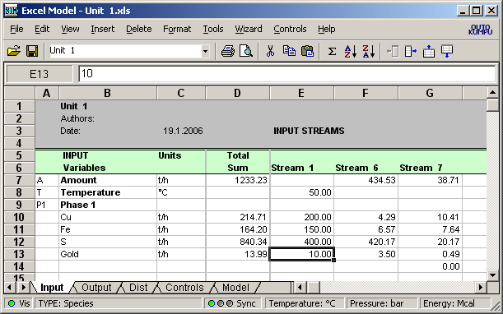
Fig. 48: Specification of raw material amounts.
You must give some amounts for the raw materials before you test your models. You may double click the raw material stream in the flowsheet, Fig. 27. In this process, Stream 1 is the only real raw material stream and the other input streams are internal ones. In this case you must specify only Stream 1 amounts, Fig. 48. You may also give some amounts for circulating Stream 6 and 7, although these amounts will be overwritten by the calculation routine which transports the data from source unit to the destination unit.
It is recommended to use the same measure units for all the species (t/h) in the first HSC-Sim versions, although in later versions a full range of units will be supported. Note that you may change easily the number format of the variable row using Variable Type Editor, Fig. 3, or using "Format, Cells…" menu selection.

40.8 Running Simulation
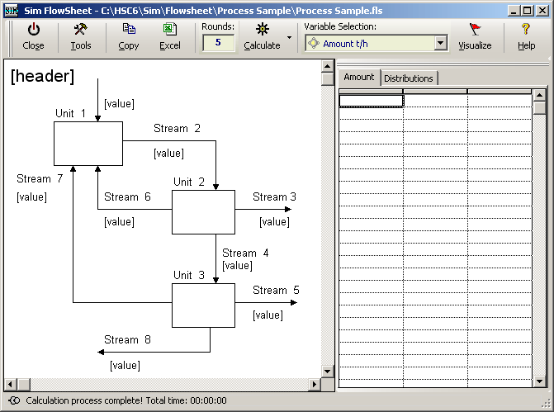
Fig. 49: View of Run Mode. You may start calculations by pressing the Calculate icon.
When you have created the process model in Designer mode then you may start the simulation mode by pressing the Start Simulation icon or by selecting "Run, Start Simulation…" from the main menu, Fig. 1. However, please save your process first using the "File, Save Process" or "File, Save Process As…" options because this allows recovery after any MS Windows or HSC-Sim errors.
The starting of Run mode may take a little time, Fig. 49, because internal calculation plan table will be created to optimize the calculation speed. So you may change the content of cells in the Run mode, but do not move cells, rows or columns in Excel Model, because this does not update the internal calculation plan.
In the Run mode the flowsheet is locked. However, you may open Excel Editor in the same way as in the Designer mode and change the raw material amounts or some other parameters. However, please do not add variables, change formulas, or modify models in the Run Mode. You may use also Variables ToolBar to change values, see Fig. 50.
The first step in the Run mode is usually to press the Calculate icon, which will carry out the calculations and move material downstream. This procedure will be executed 5 times, or any other number of iterations that you specify in the Rounds text box. If you have no internal circulation streams then some 1 - 2 rounds are enough but if you have a lot of internal circulations then more iterations are needed. You may select a critical stream on the Variables ToolBar before pressing Calculate and observe the stabilization of the composition. When the changes stop then equilibrium has been reached.
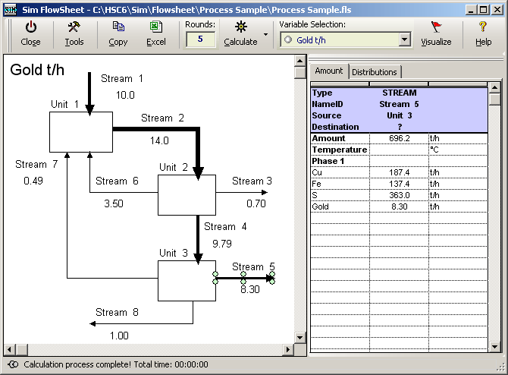
Fig. 50: Run Mode: the Visualize option has been selected for Gold. Stream 3 has been selected for the Variables ToolBar.
When you have carried out the calculations the flowsheet is automatically updated with the selected Variable data. You may change this selection using the Variable Selection drop-down list box, Fig. 50. You may use the Visualize selection to change default visualize settings. Visualized flowsheets offer an illustrative way to report the simulation results. The Visualize options make it possible to adjust line widths or the range, etc. These diagrams are sometimes called "Sankey diagrams". . Note that the HSC-Sim module draws Sankey diagrams automatically.
You may easily Copy-Paste the visualized flowsheet into other Windows applications by pressing the Copy icon. Then Paste the flowsheet into Word or Excel using the "Edit, Paste Special…, Picture, OK" procedure.
You may also print and export the flowsheet as a file using the Tools menu options, see Fig. 26. Several graphics formats are supported.
Another useful option is "Show Calculation Monitor". This will show details of the calculation in table format, Fig. 51. It may be used to identify possible convergence problems with Controls and circular internal streams, Fig. 52.
Monitoring Iterations and Controls
You may monitor calculations progress and control iterations by "Tools, Show Calculation Monitor" selection, see Fig. 51, 52 and 53.
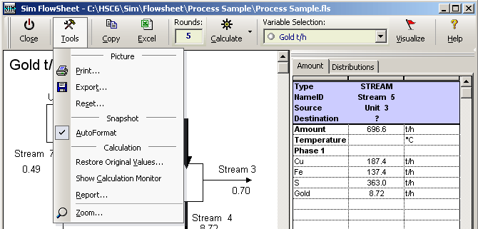
Fig. 51: Run Mode: Tools menu options.
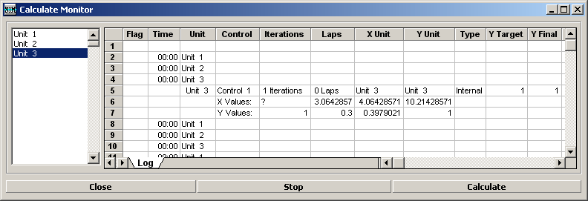
Fig. 52: Run Mode: Show Calculation Monitor Dialog may be used to follow the calculations.

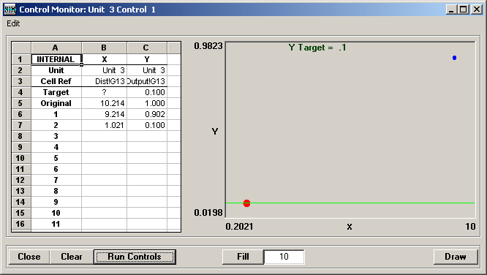

Fig. 53: Show Calculation Monitor Dialog may be used to show the Control Monitor.
The Control monitor, Fig. 53, shows the iteration convergence of the active selected control. Note that:
- Excel Editor of one unit must be open
- Control sheet must be open
- One control must be selected.
You may then test the iteration of the active selected control by pressing the Run Controls button. This gives the extrapolates values in number and in graphical format.
40.8.1 Visualize Settings Dialog
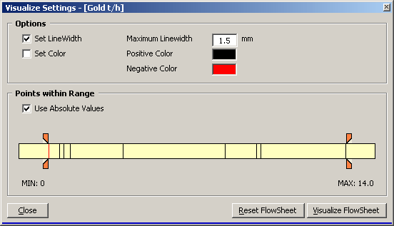
Fig. 54. Visualize dialog. Gold is an active variable in this case.
The stream variable amounts may be visualized using the HSC-Sim Run mode Visualize option. The Visualize Settings dialog may be used to change the Visualize options.
The Visualize dialog settings, Fig. 54 are:
Set Line Width Varies stream line width
Set Color Varies stream color with positive and negative values
Maximum Line Width Maximum line width with maximum amount
Positive Color Stream line color if value is positive
Negative Color Stream line color if value is negative
Use Absolute Values Automatic line width
MIN User selected minimum value
MAX User selected maximum value
Close Closes the dialog
Reset Flowsheet Recovers default line widths
Visualize flowsheet Shows the effect on the flowsheet
Note that flowsheets do not calculate anything, they only show the stream line widths using the given variable values.
40.9 Printing
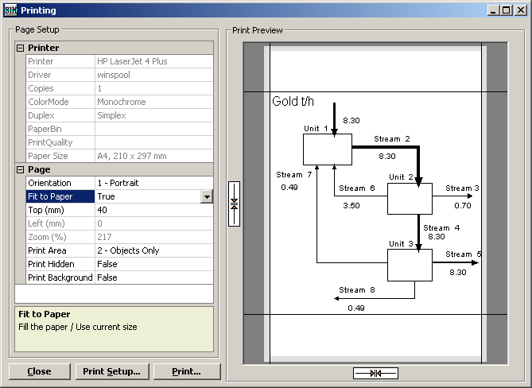
Fig. 55. Flowsheet module Print dialog with Print Preview.
The same printing dialog is available in the Flowsheet Design and Simulation mode, Fig. 55. The Print Preview on the right side shows the effect of selected printing properties on the print results. The narrow gray area on the edges of the paper shows the area where the printer cannot print. The property list on the left shows the available settings such as:
- Printer: Print Setup changes
- Driver: Print Setup changes
- Color Mode B&W / Color
- Paper Size Print Setup changes
- Orientation Portrait / Landscape
- Fit to Page True / False
- Top Top margin. Black horizontal line in Preview.
- Left Left margin. Black vertical line in Preview.
- Zoom Zoom setting used in printing.
- Print Area Picture / Objects only
- Print Hidden Objects Also prints object of which the visible property is False.
- Print Background Also prints background picture of the flowsheet

40.10 Element Balances of the Units
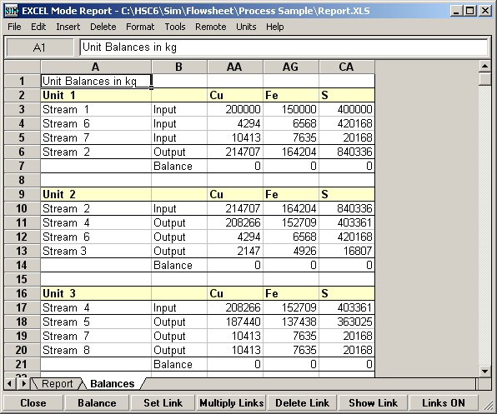
Fig. 56: Element balances of process units.
The unit calculation models made manually or using Sim Wizards may contain errors. One typical error is that the element balance between the input and output streams is not zero.
You may easily check the element balances of the units by selecting "Tools, Element Balances…" in the Model Editor menu, Fig. 2. This will start the procedure to calculate the element balances of all the units and give these on the Balances sheet of the Report form, Fig. 56. This procedure will hide those element columns which do not contain material.
This procedure calculates element balances based on the input and output stream elements. It also takes into account the possible species (FeO, NaSO4, etc.) in the variable list. However, it cannot take into account the elements which are hiding behind the variable names such as "Gold". If you want the Element Balance procedure to check the element balances, please use chemical formulas (Mg, Ca, SiO2, SO2(g), SO4(-2a), etc.) as species names in the variable list.
You may save, print and Copy-Paste the element balance results collected on the Sim Report form using normal menu selections, Fig. 56. When you save an FLS file the Report.XLS file will be automatically saved in the same folder.
40.11 List of Streams - Variable Balances
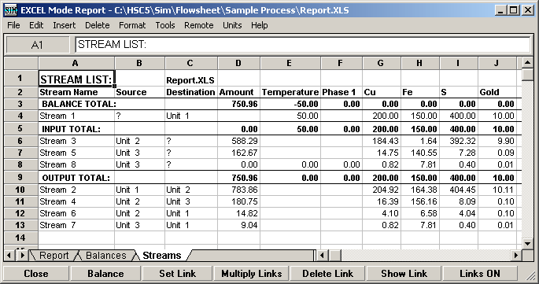
Fig. 57: List of input, output and internal Streams with variable balances.
Quite often the results of the simulation calculations are presented as a stream list with calculated variable values.
You may easily generate a stream list with values and variable balances by selecting "Tools, List Streams…" in the Model Editor menu, Fig. 2. This will collect the streams on the Streams sheet of the Sim Report form. This procedure will also sort streams into three categories: Input, Output and Internal streams, Fig. 57. In this list all the variable names will be shown in row 2.
Please note that this is not an element balance, instead it is a variable balance and the variable balance does not need to be zero for the process. For example, if the Al2O3 is converted into metallic aluminum Al then the Al2O3 balance of the process cannot be zero!
When you save the FLS file the Report.XLS file will be automatically saved in the same folder.
40.12 Creating Controls
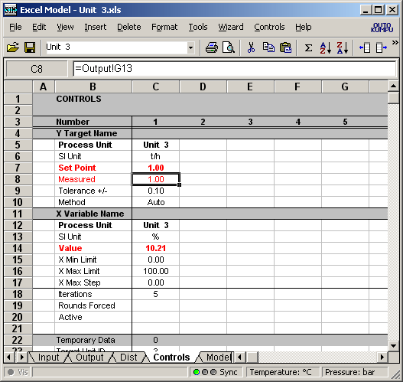
Fig. 58: The calculation model “Controls sheet” with one control.
Row Name Description
3 Number Control Number (max = 254)
4 Y Target Name Name of Y (optional)
5 Process Unit Unit name (optional)
6 SI Units Measure unit name (optional)
7 Set Point Set point of Y (obligatory)
8 Measured Y cell reference (obligatory)
9 Tolerance +/- Y tolerance (obligatory)
10 Method Iteration method (obligatory)
Auto (default, run process until Y oscillation ends)
Auto Slow (run process "Rounds Forced" times)
11 X Variable Name Name of X (optional)
12 Process Unit Unit name (optional)
13 SI Unit Measure unit name (optional)
14 Value X cell reference (obligatory)
15 X Min Limit Min limit of X range (obligatory)
16 X Max Limit Max limit of X range (obligatory)
17 X Max Step Maximum X Step (optional, default = 0 = not in use)
18 Iterations Max iteration number (obligatory)
19 Rounds Forced Run process given times (optional, default = 0 = not in use)
20 Active Set control ON/OFF (optional, default = ON)
The HSC-Sim Controls sheet makes it possible to create controls which regulate some target parameter cell value using some other variable cell value, Fig. 58. In principle, Sim Control works exactly like real process control, for example, in a real process unit you may give a set point to process unit temperature and regulate the temperature using the fuel oil feed.
You may create two types of controls:
1. Internal control where the target and variable cells exist in the same unit (FAST).
2. External control where the target and variable cells exist in different units (SLOW).
Calculation of the internal control is fast because only one unit is calculated. Calculation of external control may take more time because material must be recirculated within the whole process several times to reach a stable target value. You may speed up iterations of external controls with narrow X min and X max limits and reasonable tolerance value. It is recommended to moderate large changes of the variable with use of X Max Step. This will usually prevent the external control to run the process out of order.
To create one control on the Controls sheet, you have to set at least the Target cell reference and Variable cell reference and also the limits for the variable. You may type this information onto the Controls sheet manually or you may use the Controls menu options. Please use the following procedure:
1. Click the first available controls column (C ->) on the Controls sheet.
2. Locate the Target cell from your active unit and select "Controls, Set Unit Target".
3. Type the name and measure unit into rows 4 and 6 (optional).
4. Locate the Variable cell from your active unit and select "Controls, Set Unit Variable".
5. Type the name and measure unit in rows 12 and 13 (optional).
6. Type Limit Min and Max in rows 15 and 16, a narrow limit speeds up calculations.
7. Give the maximum number for the iterations in row 18.
If you want to use an external target cell from some other process unit then use "Set Process Target" and "Set Process Variable" selections. This will open the unit selection dialog, which may be used to guide the external cell reference to the correct unit.
The default Tolerance is +/-. The small tolerance increases calculation time and large tolerance increases errors. Some 2% of the target value may be a good compromise. The control will not be calculated if the value is within the tolerance.
The Controls sheet uses Auto Method to iterate target value by changing a variable value if the Method is not specified. Other valid methods are:
  - Auto: Default method, combination of Tangent and Least Square method. This method will change variable X value and it will stop iteration when target Y value oscillation ends. Usually, "Auto" is the best selection.
  - Auto Slow: Similar to previous, but with the external controls force to run process as many times as given in "Rounds Forced" cell. This will make possible to control the "slow processes".
Sim Controls have exactly the same limitations as real process controls, for example:
- If the target cell does not depend on the variable cell value then the iterations will fail.
- If an external variable cell is used then there may be a long delay before the effect on the target value is visible. In these cases a lot of iteration rounds may be needed to reach the set point. This may increase the calculation time.
The first HSC-Sim version used the old HSC Chemistry software iteration routine, which assumes an immediate response between the variable change and the new target value. In the basic HSC this is always a valid assumption. However, in the HSC-Sim module the response of the target value to the variable change may involve delays, especially if the target and variable cell references are located in different process units. In future HSC-Sim versions more effort will be put into developing Controls iteration routines.

PLEASE NOTE:
- Usually you may create a large number of internal controls in a process without a dramatic drop down of calculations speed because these do not increase the number of calculation rounds of the process.
- Usually only a few external controls can be used in one process without considerable decrease in the calculation speed because external controls may multiply the calculation rounds of the process.
- It is recommended to moderate large changes of the variable with use of X Max Step, when using external controls with slow respons.
- If you want to keep some concentration lower than a set point (8 g/l) by changing bleed stream amount (valve 0 - 100%). Please use an external control if the bleed and concentration cells exist in different units.
- The RecoveryX add-in function cannot be used in the Target cell, because it is recalculated only after all calculation Rounds have been finished.
- The large number of thermochemical add-in functions (StreamH, StreamS, etc.) may drop down calculation speed if the argument value changes in each control iteration round because the data search from the H, S and Cp database takes time. Use these add-in functions only when needed.

40.13 Remote Control - Scenarios - Sensitivity
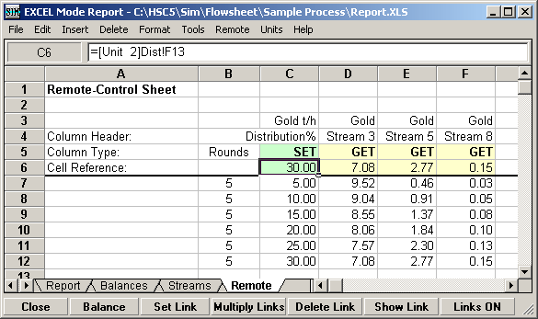
Fig. 59: Sim Report form showing the Remote Control results.
Sometimes you may want to run the simulation by changing one or several variables or parameter values in the process several times. This may be done manually but the Sim Remote Control tool can be used to automate this kind of scenario or sensitivity analysis.
You may create a new Remote Control by selecting "Remote, Create Remote-Control…" from the Report form menu, Fig. 59. You may fill in the Remote sheet using the following steps:
1. The first step is to collect cell references in row 6. Locate the variable cell from the calculation model, Fig. 48, and press Set Link on the Remote form, Fig. 59. You may also type cell references manually, note that the Unit name must be in brackets, [Unit 2], and the sheet name must end with an exclamation mark, Dist!.
2. Then click cells C5, D5, E5, etc. to specify the variable type SET/GET. The SET variable sets the value and the GET variable reads the values. Note that the SET cell must contain a value not a formula!
3. Fill in the SET values in the SET columns starting from row 7, and enter the number of Rounds in column B. A large number of Rounds increases the calculation time.
4. You may type some headers for rows 1 and 4, just for your own use.
5. Run the Remote Control by selecting "Remote, Run Remote-Control", Fig. 59.
6. The Sim Remote control tool runs the simulation several times by changing the SET cells by the given values and collects data in the GET columns.
When the simulation has ended you may Save, Print and Copy-Paste the results using normal menu selections, Fig. 29. When you save the FLS file, the Report.XLS file will automatically be saved in the same folder.

40.14 Creating Reports
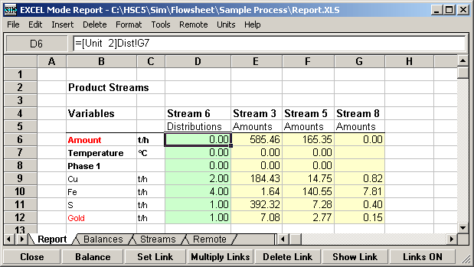
Fig. 60: Sim Report form with a report on product streams.
Visualized graphical flowsheets are often the most illustrative way to report results. However, sometimes some key figures are needed in tabular format. The HSC-Sim Report dialog may be used to collect and modify the necessary data from the calculation models. Using the selection “File, Report”, may open this tool. Please use the report sheet for collecting results; the Balances, Streams and Remote sheets are reserved for other purposes, Fig. 60. Note that you may also insert other sheets for you own purposes.
You may pick up any data from the calculation models using external links. You may type these links in the Report sheet cells manually or you may select the necessary cell from the unit model (Set Link Source Cell) and then press the Set Link button at the bottom of the Report form. Please use the correct syntax in the external links. Formula: "=[Unit 2]Dist!G7" links the cell to cell G7 of the Dist-sheet in Unit 2.
The green pattern of the cell means that the linked cell contains no formula, which means that you may type a new value in the Report sheet and it will be transferred into the source cell too. i.e. green cells contain two-way bidirectional links. The yellow pattern means that the source cell contains a formula, and this means two-way links cannot work with these cells. The green two-way links allow you to change some process parameters quickly and recalculate the process and collect new data in the yellow cells.
You may format the Report sheet in the same way as you format an Excel sheet. A Report.XLS file is automatically saved in the same folder as the FLS process file when you save the process.
Multiply Links may be used to link the same cells in each unit in the Report sheet. For example, select cells G6:G12 and press Multiply Links.
The Show Link button will show the source cell of the selected external link. The Links ON button may be used to set Links OFF in order to speed up the calculations. The Balance button calculates the element balances of the units.

40.15 Global Cell Editor
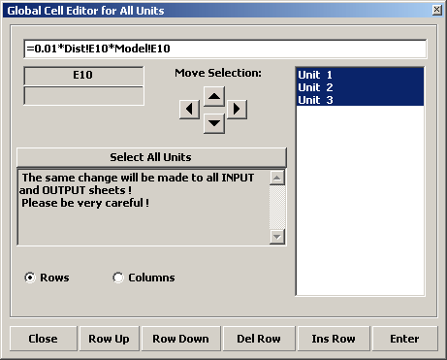
Fig. 61: Global Cell Editor edits all units simultaneously.
The Synch option at the bottom of the Model Editor form, Fig. 2, synchronizes all the changes made to the variable list in the Input, Output and Dist sheets columns A - D in all units. However, sometimes you may want to make such changes in other sheets and cell ranges too. The Global Cell Editor is made for this kind of work.
You can open Global Cell Editor by selecting: "Tools, Cell Editor…". This will open the active cell for global editing. You may retype anything in the Global Cell Editor text box and when you press Enter it will be transferred to all units which have been selected in the unit list at the right side of the dialog.
You may also move, insert and delete rows globally in all selected units.
Please be very careful with this tool, you may easily destroy your models with this tool if you are not absolutely sure of what you are doing.
40.16 Calculation Model Appearance and Format
The row and column order of Input, Output, Dist, Controls and partially also on the Model sheet is fixed. However, the appearance and formats are quite free. In your own sheets the layout and formats are totally free.
The default calculation model format may be set using the file:
C:\HSC6\Template Model.XLS
You may edit the number, color, border, pattern, etc. formats of this file using MS Excel. If you want to return to the original formats then delete this file, it will be recreated if it does not exist in the same folder as Sim.exe.
If you want to update old models using new template formats then select: "Format, Unify Using Template Model…" which will update the formats of all the units using the formats of the "Template Model.XLS" file. You may also unify by selecting "Format, Unify Using Active Model…".
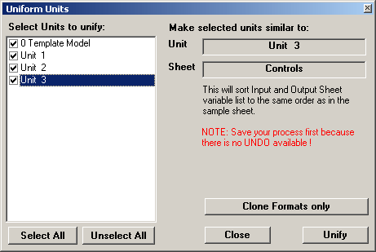
Fig. 61: Unit Unify Dialog.
You may also unify selected units only using the format of the active unit. You may open the Uniform Units dialog with the selection: "Tools, Unify Sheets…".

40.17 Density of Aqueous Solutions
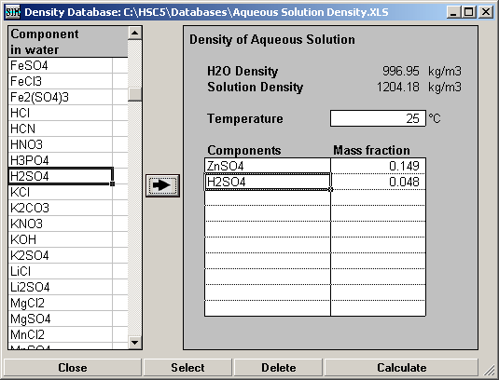
Fig. 62: Aqueous solution density calculator.
The HSC main database contains data of densities of gases and condensed substances, however, the densities of aqueous solutions must be calculated using the density calculator and Aqueous Solution Density database, Fig. 62. This calculator may be opened using the "Tools, Density Calculator…" menu selection. Aqueous solution densities are needed, for example, to convert analyzed concentrations in g/ml into quantities.
You may pick up aqueous solution components from the list on the right side of the form, then the second step is to specify mass fractions and temperature, then pressing Calculate will give the results. The densities are based on mass fractions because this type of experimental data is available and the calculation model uses this primary data. Aqueous solution density is quite easy to measure experimentally but difficult to evaluate theoretically. You may add new data into Aqueous Solution Density.xls file using MS Excel. See details of the basic ideas from chapter 40.17.1
These fixed density values may be used in HSC-Sim based models. However, the DensityA(Species;Amount;T) AddIn function may also be used to give the densities as a function of arguments in the models. DensityA uses exactly the same calculation routine and database as the aqueous solution density calculator, Fig. 62. See example in:
C:\HSC6\AddIns\AddInSample.XLS
40.17.1 Density Calculation Methods

The density calculation for aqueous solutions was made according to the article written by M. Laliberté and E. Cooper. It is based on the mass fractions of the electrolytes in the solution. The database includes constants for 59 electrolytes and more constants can be added to the database if measurements of the solution of an electrolyte are available.

In HSC Sim, the density calculation may be done using Excel Add-In function DensityA. For source information it needs the components, their mass fractions and the temperature of the solution. The result is the density of the solution in the unit kg/m³.

The Excel Add-in calculates first the apparent specific volume for each electrolyte and then the density for the solution. The apparent specific volume is calculated with equation 1.

$v_{\text{app},i}=\frac{\left(1−w_{H2O}\right)+c_{2}+c_{3}t}{\left(c_{0}\left(1−w_{H2O}\right)+c_{1}\right)e^{\left(0\text{.}\text{000001}{\left(t+c_{4}\right)}^{2}\right)}}$ (1)

The apparent specific volume can be either positive or negative. Typically it has a low value at low concentration and then increases toward a linear relationship with mass fraction at higher concentration. The density of the solution can be calculated from the volume with the following equation:

$ρ_{m}=\frac{1}{\frac{w_{H2O}}{ρ_{H2O}}+\sum{w_{i}}v_{\text{app},i}}$ (2)

40.17.2 Adding new electrolytes to the database

To add new electrolytes to the database the constants c₀ to c₄ have to be calculated. Calculation is preformed with similar equations as presented above. First, the apparent specific volume is calculated from the measurements with the following equation:

$v_{\text{app},i}=\frac{1−\frac{ρ_{m}\left(1−w_{i}\right)}{ρ_{H_{2}O}}}{ρ_{m}w_{i}}$ (3)

The volume is used to calculate the constants c₀ to c₄. Equation 1 is used in this calculation and it reduces to equation 4 for a solution of just one electrolyte in the water.

$v_{\text{app},i}=\frac{w_{i}+c_{2}+c_{3}t}{\left(c_{0}w_{i}+c_{1}\right)e^{\left(0\text{.}\text{000001}{\left(t+c_{4}\right)}^{2}\right)}}$ (4)

The calculations of the constants were made with nonlinear least-squares method (Excel solver) when the initial guesses for constants c₀ to c₄ were 1, 1, 1, 0.0025 and 1500 respectively. Then new values for the volume and the density were calculated with the equations 1 and 2. Residuals were calculated by subtracting the calculated apparent specific volume and solution density from their experimental values. The sum of the square of the density residuals was calculated, and this value was minimized varying the constants. The data was also checked for consistency for both volume and density, by calculating average residuals and standard deviations. If a data point varies 4 times the standard deviation from the average residual, the data point is removed and the calculation is repeated until there are no inconsistent data. Because the constant c₄ can sometimes be negative the other initial guess for it was -1500 to avoid convergence problems.

Calculation spreadsheets from the source article are available free of charge via the Internet at http://pubs.acs.org.

40.17.3 List of symbols

c₀ Empirical constant, kg/m³
c₁ Empirical constant, kg/m³
c₂ Empirical constant, -
c₃ Empirical constant, 1/°C
c₄ Empirical constant, °C
t Temperature, °C
v_{app,I} Apparent specific volume of component i, m³/kg
w_{H2O} Mass fraction of the water, -
w_{i} Mass fraction of component i, -
ρ_{H2O} Density of the water, kg/m³
ρ_{m} Density of the mixture, kg/m³
40.19 Password Protection of Units
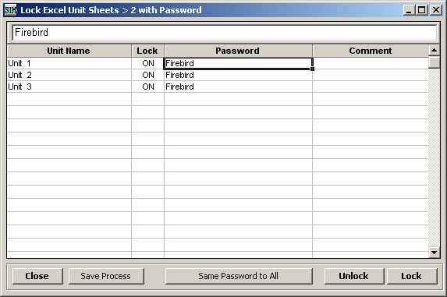
Fig. 63: Password protection dialog.
You may hide the calculation models of the process by selecting from the Flowsheet menu: "File, Lock Excel Units with Password…" Dialog, see Fig. 63:
1. Type the password to the Password column and press "Same Password to All".
2. Press the Lock button.
3. Press the Save Process button.
4. Press the Close button.
This procedure will hide all the other sheets than Input and Outputsheets and save unit files in a crypted format which cannot be opened with Excel or any other program. You may also password-protect only one unit by giving the password only to this unit.
You may open the password protection if you know the password but press the Unlock button instead of the Lock button.
Note that password protection automatically opens the cells with external references for monitoring and calculations, but all the other cells on the hidden sheets are invisible for the external references. All the "open", unprotected cells are marked with green pattern on the hidden sheets.
The password-protected units are like black-boxes, where only the Input- and Output-sheets are visible to the user. However, remember that when the final user has full access to the protected files in his hard disk, then any protection method is NOT absolutely safe.

40.18 Data Reconciliation
Data reconciliation means fitting the analyses of the streams to solve the mass flow of each stream and recalculating the analyses so that the flowsheet is internally consistent.
For that you need:
- Chemical analyses of the streams, weight based, i.e. wt.%, ppm, g/t, ppb etc.
- Knowledge of the analysis variation for each element
The steps of data reconciliation are:
  - Drawing the flowsheet and naming the streams
  - Inputting analyses
  - Creating mass balance equations
  - Solving the mass flows and assays
  - Saving the balanced result for further use

Inputting analyses:
Analyses are imported into the Analysis.xls file, which is stored in the same folder as the flowsheet.
Steps for inputting the analyses are:
1. Open the Analysis window from the flowsheet, select Tools – Analyses
2. Prepare the analyses in Excel or somewhere else in a format where:
- Row-wise data: Each sample is in its own row
- The name of the sample is the same as the stream (you can check and change that later)
- Each analyzed element in its own column
- Header data in one row, include there analyzed component, analysis method and unit, e.g. Cr2O3 XRF %, Cu TOT ppm, Au (FA) g/t,
- Name the first column where the stream name is as ‘Stream’
- Above and on the left side of the ‘Stream’ cell you may have data which is not taken into account in data reconciliation
3. Note that you do not need to have the analyses of each stream. There may be also some extra samples. These are omitted in data reconciliation, but if you like you can have them there for information or some other purpose.
4. One stream cannot appear twice!
5. Import the analyses into the Analysis window, either by opening the file (File – Open) or through the clipboard (Edit – Paste)
At this moment the analysis data should look like this (Fig. 64):
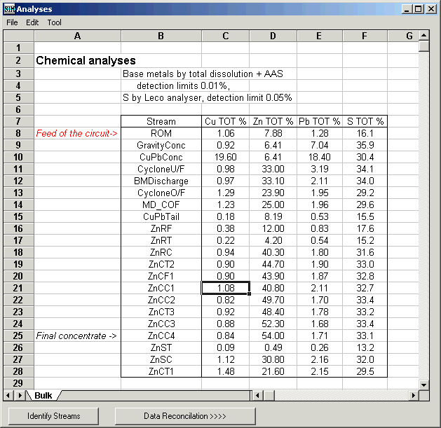
Fig. 64: Analyses. Data has to be row-wise, “Stream” cell indicates the top left corner of the analysis table. Analyses are as follows: preferentially give the element, method and unit; all in a single cell.

6. Press the “Identify Streams” button, which adds the columns Source, Destination and Mass% if required next to the ‘Stream’ column and fills it accordingly (Fig. 64). Check that the streams have the correct ‘Source’ and ‘Destination’. A question mark denotes that it is either a feed or product stream of the circuit. If ‘Source’ and ‘Destination’ are empty, then the sample has not been identified and the name of the stream is incorrect either in the flowsheet or analysis listing. Change in either place and redo ‘Identify Streams’. This listing is regenerated each time you press the “Identify Streams” button. You can change the stream names and other data as well.

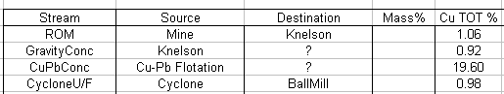
Fig. 65: After pressing ‘Identify Streams’ button the ‘Source’ and ‘Destination’ columns appear in the spreadsheet. A question mark (?) indicates that the stream is either an input (in ‘Source’ column) or output (in ‘Destination’ column).

7. Select File – Save to save the data in the same folder as the flowsheet. (Analyses.xls) Once saved, the analyses will be loaded automatically each time you open the flowsheet.
Data Reconciliation:

The data reconciliation can be done once you have input the data and identified the streams. Press the “Data Reconciliation >>>>” button in the ‘Analysis’ window. The data reconciliation window opens, see below. The window consists of five parts: 1) stream control at the top, 2) analysis control on the right, 3) unit control below in the middle, 4) options on the right, 5) mass balance info box and 6) buttons at the bottom.
The starting point of the data reconciliation sheet is that :
- All the units and streams are selected for the data reconciliation
- All elements are selected for the data reconciliation and the coefficient of variation, CV, are set to 1
- Mass balance equations are generated according to analyses. This means that while the mass balance equation is written initially for all units, in the second step the unit size is enlarged in a way that mass balance equations are fulfilled according to the analyzed samples. This means that the number of mass balance equations is reduced and some streams with analyses may be left out because their mass proportion cannot be calculated directly by mass balancing.
The steps of the data reconciliation are:
1. You may start by pressing the “Reconcile !” button and see what is the outcome of the basic assumption.
2. To do the reconciliation for only part of the flowsheet e.g. in cases where some of the streams tend to end up negative, use “Is Used” and “Analysis” columns.
- “X” indicates that the stream is selected. Click the cell and the stream switches between selected (“X”) and unselected (“ “).
- “Is Used”: if you unselect the stream in the “Is Used” column this equals the cases where the stream does not exist at all
- “Analysis”: if you unselect the stream in the “Analysis” column this equals the case where the stream has not been analyzed
- Check the mass balance equations in use at the bottom of the window
3. Click on the cell or use the Edit menu to unselect and select “Is used” and “Analysis”. Note that there is an option to select the streams of a unit. Select the unit in the flowsheet and then select from the menu “Is Used = Add selected unit”. This changes the input and output streams of the unit as “Is Used”
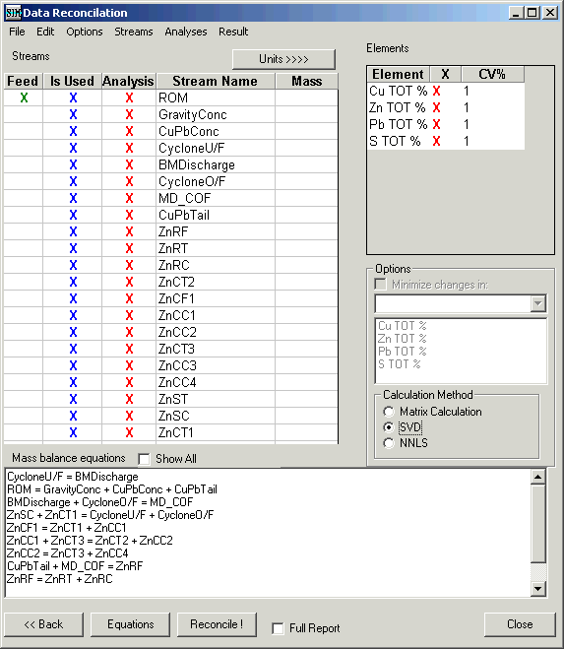
Analysis control
Stream control
Mass balance equation info box
Options
Buttons
Fig. 66: Data Reconciliation window.
4. By fine-tuning the weighting of analyses: on the right side of the window in “Analysis control” you can fine-tune the effect of each analysis. Again “X” means that analysis of e.g. copper is taken into data reconciliation while sulfur can be excluded.
5. CV, the coefficient of variation: the weighting of the analysis is adjusted on the basis of the coefficient of variation. A low CV value, e.g. 1, means that the analysis is highly reliable whereas a high value, >10, is used for low accuracy and low reliability. In mass balancing the analyses are changed according to the formula: used=analyzed/(CV*content_in_feed).
6. If you cannot get rid of negative values, switch to the NNLS (non-negative least squares) method. Be careful that, there may be something wrong with the original analyses; and a better way could be to uncheck the problematic streams (“Analysis”-column).
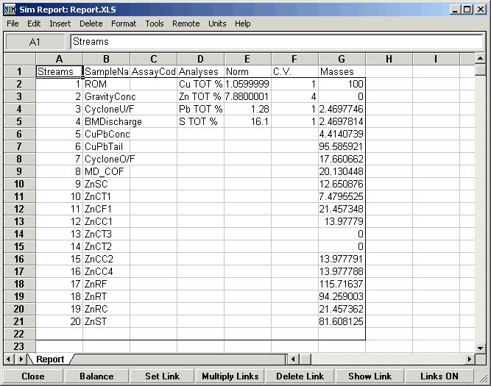
Fig. 67: Result of the data Reconciliation in the Sim Report window.
7. Once you are happy with the results as shown in the Report window you can save the output back in the Analysis.xls file. To do that select from the reconciliation window menu ‘Results’ – ‘Write into Analyses’ (Fig. 68). HSC Sim asks for the name of the sheet for the output (Balanced as default). If it does not exist, a new sheet will be created and reconciled data will be written there. If one exists, the sheet will be emptied and replaced with the new data.
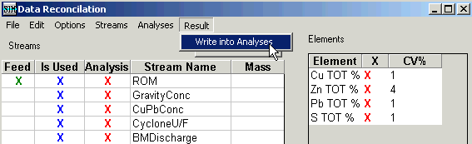
Fig. 68: Writing the result back in the Analysis window.

8. To complete the data in the ‘Balanced’ sheet in the ‘Analysis’ window, press ‘Identify streams’ and select from the menu ‘Tools’ – ‘Calculate Recoveries’. Recoveries are calculated against the first row (Fig. 69). To save the result select File – Save (Fig. 69).
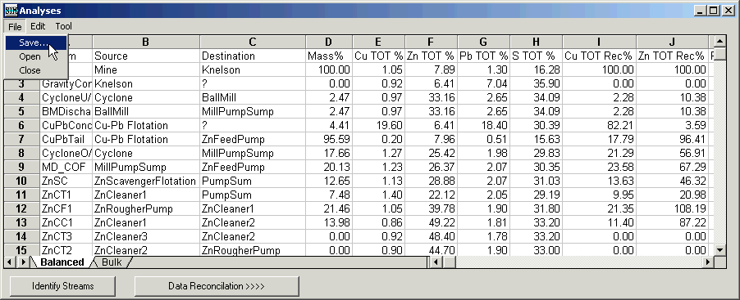
Fig. 69: Balanced result as complete in the ‘Balanced’ sheet with ‘Source’ and ‘Destination’ information (by pressing ‘Identify Streams’) and recoveries (by selecting Tools – Calculate Recoveries). Save the data by selecting ‘File’ – ‘Save ...’.

